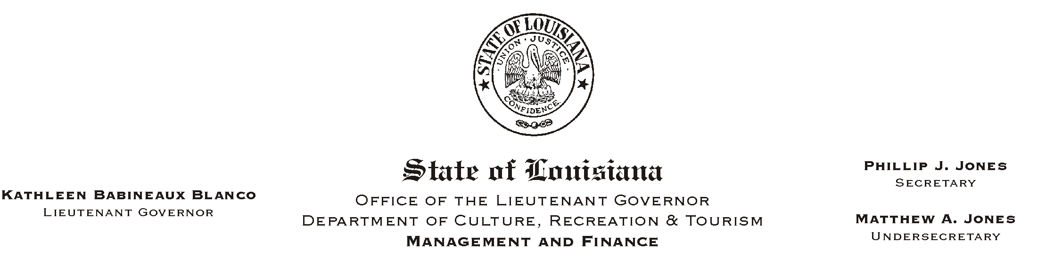
HUMAN RESOURCE MEMORANDUM NO. 01-007

January 18, 2001

TO: Lt. Governor, Secretary, Deputy Secretary, Undersecretary, Assistant Secretaries, Deputy Assistant Secretaries, Program Managers

FROM: Mary F. Ginn
Human Resources Director

SUBJECT: The Disney Club

The Magic Kingdom Club has changed to the Disney Club. Enrollment in the Disney Club now costs $29.95 for a one-year family membership. As an employee of the department, you will now save $10.00 off the regular cost of $39.95. With membership, you can receive year-round discounts on passes for the different theme parks, on lodging and vacation packages, as well as many other privileges. (See the enclosed pamphlet for more details.)

Employees can also request the Disney Sampler free of charge. This is a booklet of some of the discounts that you receive belonging to the Disney Club. Each employee may request only one of these booklets per year. (A sample of the discounts is enclosed for your review.)

You can contact anyone in the Human Resources Office for more information, a brochure to enroll in the Disney Club or to receive a free Disney Sampler. Once a brochure is requested and received by the employee, the employee is to fill it out and return the bottom half to us so that it can be sent to Disney for activation.

Enclosures
Please Post and Circulate

