January 2, 2001
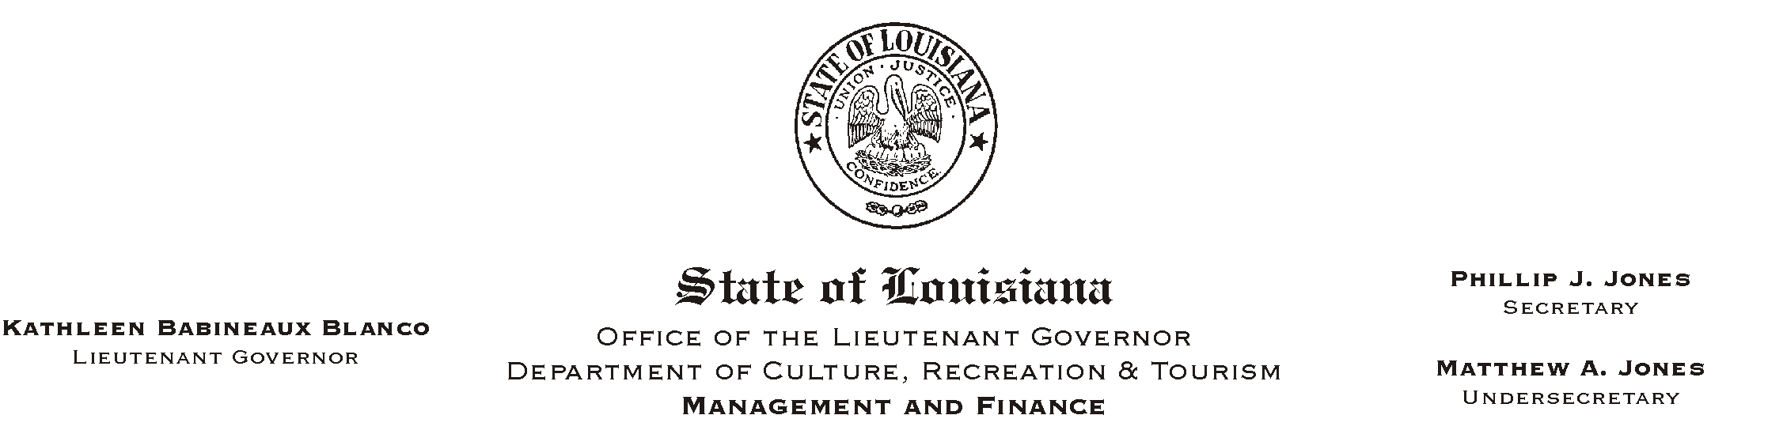

TO: Lt. Governor, Secretary, Undersecretary, Assistant Secretaries, Deputy Assistant Secretaries, Program Managers

FROM: Mary F. Ginn
Human Resources Director

SUBJECT: Urgent Message For Members of the
Please Post and Circulate
State Employees= Group Benefits Plan (SEGBP)

Employees were recently notified in Human Resource Memorandum 00-056 of changes in the State Group health plan, effective January 1, 2001.

On December 19, 2000, the Louisiana House Appropriations Committee rejected these changes. Therefore, the changes in benefits listed in the aforementioned memorandum will not take place. No changes are expected to go into effect until recommendations are proposed by a special study commission.

Accordingly, Ochsner and Gulf South Health Plans will be rescinding the planned implementation of a $150.00 deductible on prescription drugs. Gulf South, however, still intends to drop Our Lady of the Lake Hospital from its network of providers, effective March 3, 2001.

NOTE: Information on the State Employees= Group Benefits Program, including the Summary of Benefits, Newsletter, HMOs, PPO Directory, Life Insurance, Frequently Asked Questions (FAQ), etc., is always available on their web site located at www.groupbenefits.org.

