January 8, 2001
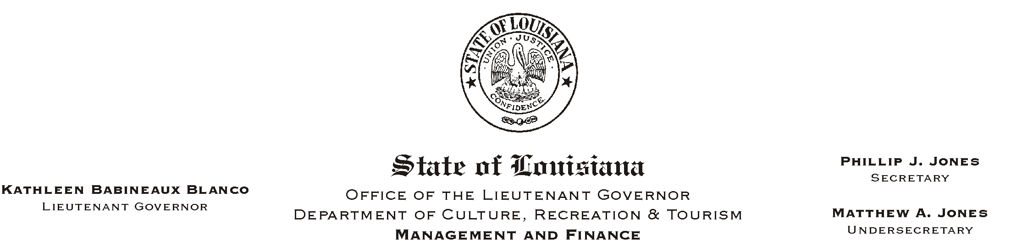

TO: Lt. Governor, Secretary, Undersecretary, Assistant Secretaries, Deputy Assistant Secretaries, Program Managers

FROM: Mary F. Ginn
Human Resource Director

SUBJECT: Holiday Proclamation
Please Post and Circulate

The Governor has declared Monday, January 15, 2001 a legal holiday to commemorate the Birthday of Dr. Martin Luther King, Jr.
HUMAN RESOURCE MEMORANDUM NO. 01-002

If you have any questions, please call the Human Resources Office at (225) 342-0880.

