January 25, 2001
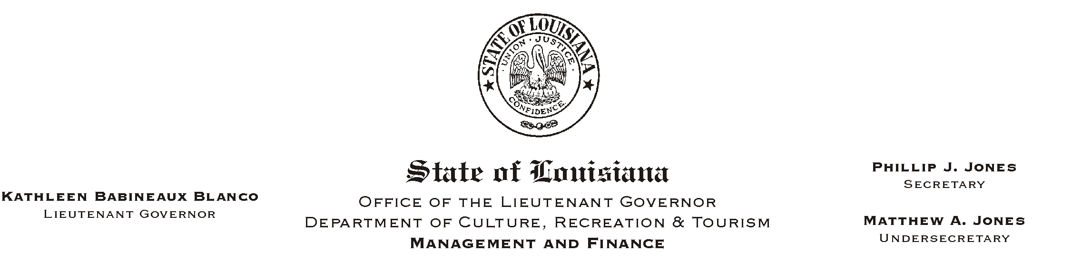

TO: Lt. Governor, Secretary, Undersecretary, Assistant Secretaries, Deputy Assistant Secretaries, Program Managers

FROM: Mary F. Ginn
Human Resources Director

SUBJECT: Office of Risk Management (ORM) Safety Course
Please Post and Circulate

Attached is a notice regarding the latest safety course offered by the Office of Risk Management (ORM).
HUMAN RESOURCE MEMORANDUM NO. 01-008

These courses are designed primarily for employees who perform safety functions in their jobs, such as safety coordinators and officers, and for managers and supervisors who have a need to know ORM safety requirements.

Approved registrations (a registration form is attached to this memo) should be faxed to Ms. Margie Washington at ORM, (225) 342-8418, as soon as possible. Classes are filled on a first come, first served basis. Certificates of completion will be provided upon completion. Records of attendance must be maintained by the Safety Coordinator within each office and copies forwarded to the Human Resources Office for the departmental safety files.

If you have any questions, please call the Human Resources Office at (225) 342-0880.

Attachments

