January 30, 2001
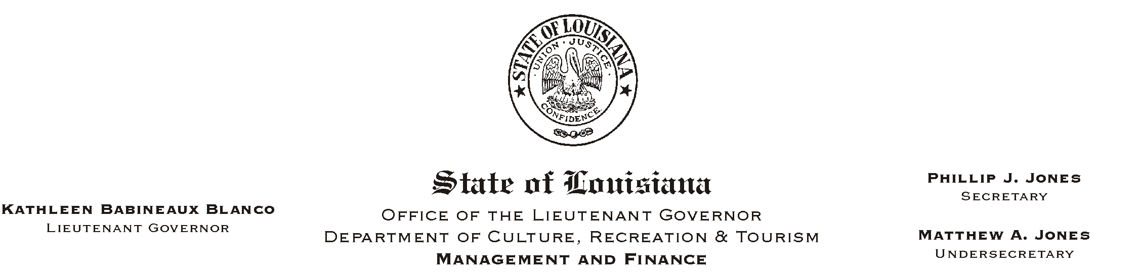

TO: Lt. Governor, Secretary, Undersecretary, Assistant Secretaries, Deputy Assistant Secretaries, Program Managers

FROM: Mary F. Ginn
Human Resources Director

SUBJECT: Prior State Service Questionnaire
Please Post and Circulate

As you are aware Human Resources has moved to the new ISIS HR system. In the conversion, some information may not have correctly transferred.
HUMAN RESOURCE MEMORANDUM NO. 01-010

Returned Employee Notification Forms in many cases have shown incorrect adjusted service dates. In order to verify our records, we are asking all employees to complete the attached newly-revised Prior State Service Questionnaire and return it to Human Resources by February 23, 2001. An incorrect service date could affect the rate at which an employee earns sick and annual leave. It is very important that every employee completely and correctly fill out this form.

Thank you for your patience and assistance in this very important endeavor. If you have any questions, please call the Human Resources Office at (225) 342-0880.

Attachment

