January 30, 2001
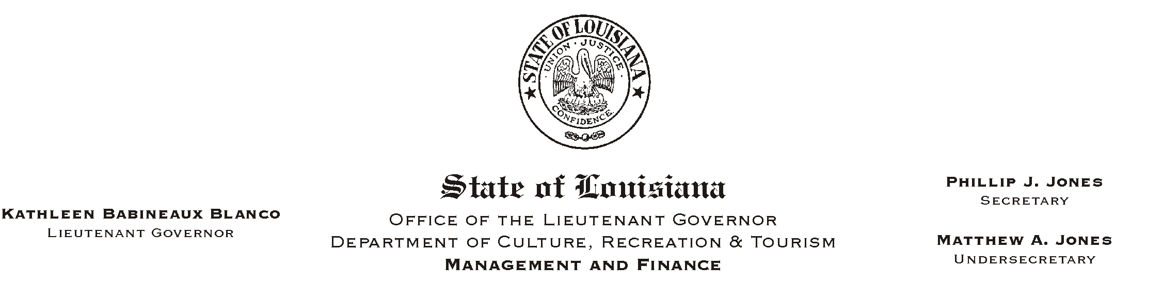

TO: Lt. Governor, Secretary, Undersecretary, Assistant Secretaries, Deputy Assistant Secretaries, Program Managers

FROM: Mary F. Ginn
Human Resources Director

SUBJECT: New Hire Checklist Revised/New Prior State Service Questionnaire
Please Post and Circulate

Enclosed are copies of the revised New Hire Checklist (02/01) and Prior State Service Questionnaire to be used for orientation of new employees. As before, the New Hire Checklist will be divided into three sections: Employment Forms & Orientation; Benefits Orientation; and Orientation by Employing Office or Section. Benefits orientation is now only required for new hires who are benefits-eligible. Please note the following additions and/or changes and begin immediately using the updated forms:
HUMAN RESOURCE MEMORANDUM NO. 01-011

- Prior State Service: This form is used to help determine the adjusted service date of new employees for both layoff and leave accrual purposes. It is very important that every new employee completely and correctly fill out this form.

- Work Permit/Intention to Employ Minors Under 18: A Work Permit from the Department of Labor must be obtained prior to employment date if employee is under age 18. The attached form, Intention to Employ Minors Under 18, needs to be completed by the employing agency with parent=s signed consent at bottom. (Please refer to Human Resources Memoranda 99-011 and 99-048.) If the minor is hired as a student employee, a Student Application (SF-10D Form), certified by the school that the employee is a full-time student, is also required.

If you have any questions, please call the Human Resources Office at (225) 342-0880.

Attachments

