February 9, 2001
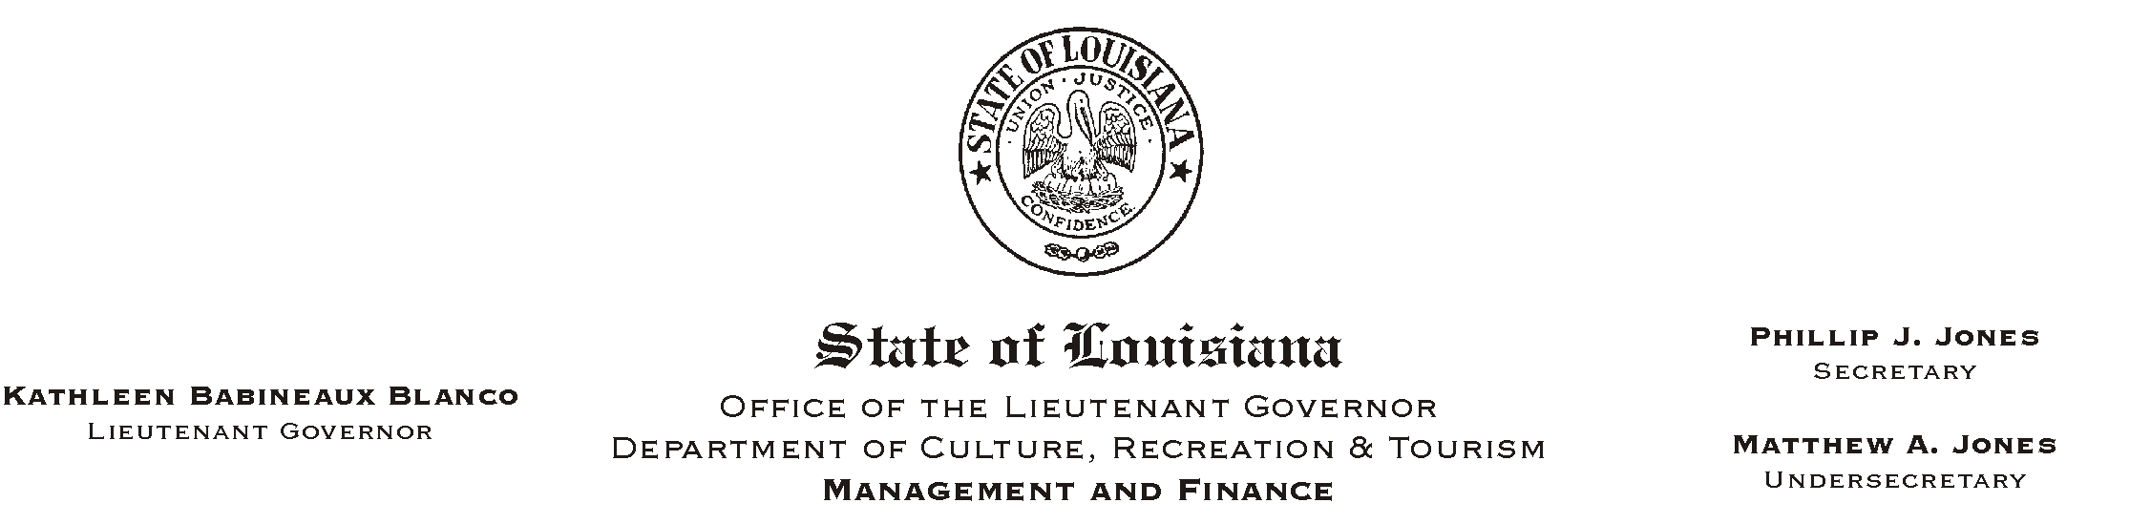

TO: Lt. Governor, Secretary, Undersecretary, Assistant Secretaries, Deputy Assistant Secretaries, Program Managers

FROM: Mary F. Ginn
Human Resources Director

SUBJECT: A Lunch & Learn Workshop - AParental GuidanceBAn Adult Guide to Preventing Underage Drinking@
Please Post and Circulate
(Another in our series of informational meetings on health and safety)
Parental GuidanceBPreventing Underage Drinking
Ms. DC Sills of Parental Guidance
Thursday, February 22, 2001
11:30 a.m. - 1:00 p.m.
Seminar Center, State Library

You are invited to a Lunch & Learn Workshop presented by Ms. DC Sills of the Parental Guidance campaign, a partnership of the Louisiana Highway Safety Commission, the Louisiana Alliance to Prevent Underage Drinking and Louisiana SADD (Students Against Destructive Decisions). The campaign=s goal is to prevent underage drinking by creating awareness of the role adults play in youth accessibility to alcohol, and the consequences of supplying anyone under 21 with alcohol.

We will plan to eat lunch at 11:30 and the presentation will begin at 12 noon. Employees can order a gourmet box lunch from AUnique Cuisine@ or bring their own lunch. Those who wish to attend the presentation only should still register and arrive no later 12 noon.

HUMAN RESOURCE MEMORANDUM NO. 01-012
This workshop will also serve as a safety meeting. Please complete the attached registration form and submit to the Human Resources Office no later than Monday, February 19, 2001. Those interested can also register on-line on AChannel Z.@
Please Post and Circulate

Attachment

