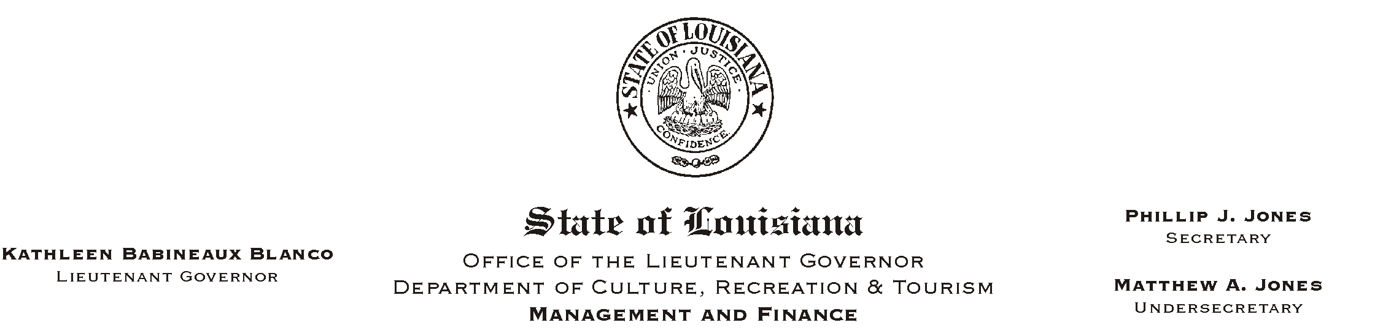
HUMAN RESOURCE MEMORANDUM NO. 01-015

February 19, 2001

TO: Lt. Governor, Secretary, Undersecretary, Assistant Secretaries, Deputy Assistant Secretaries, Program Managers

FROM: Mary F. Ginn
Human Resources Director

SUBJECT: Astroworld Coupons

Astroworld coupons are now available. The coupon is buy one get one free for up to fifteen tickets. The price of a one-day admission to Astroworld is $24.99 plus tax.

If you are interested in a coupon, please contact the Human Resources Office at (225) 342-0880.

Please Post and Circulate

