March 1, 2001
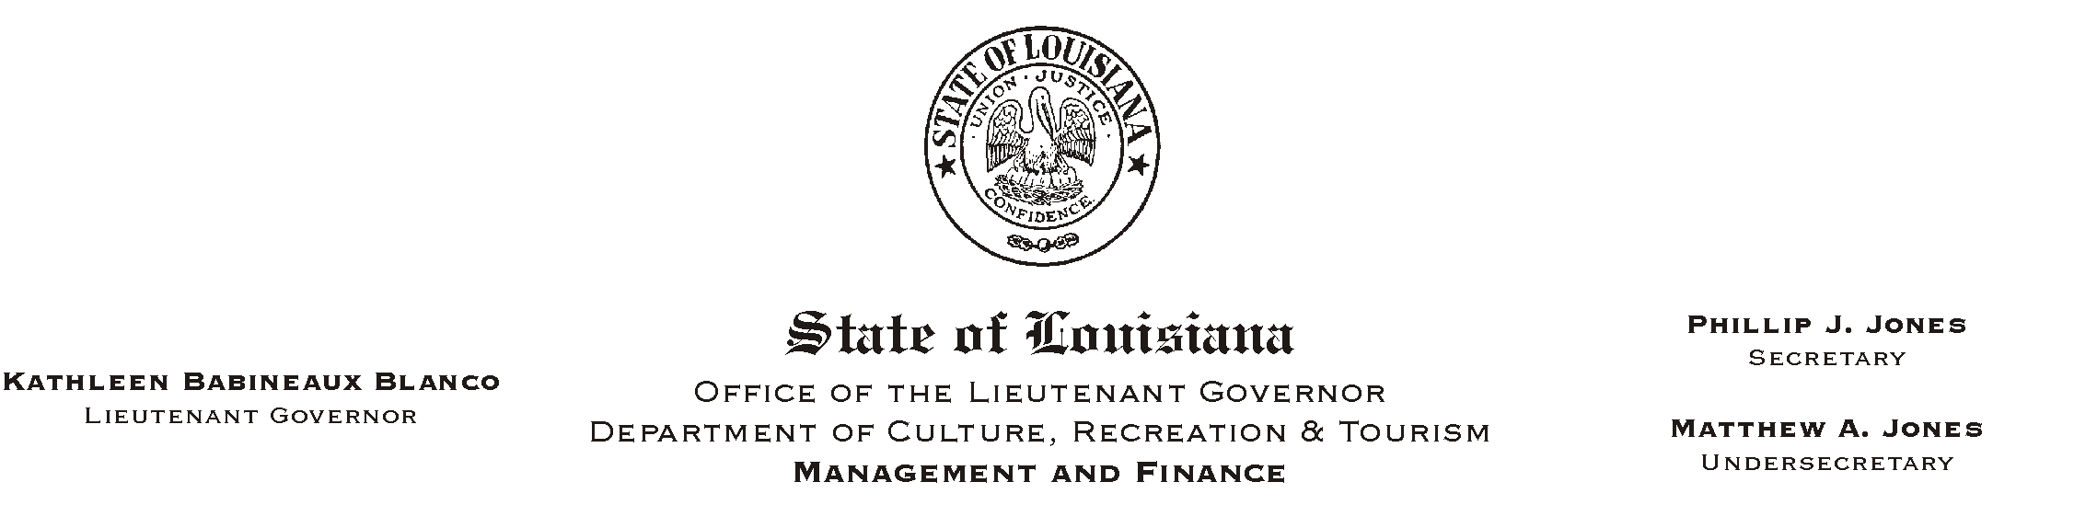

TO: Lt. Governor, Secretary, Undersecretary, Assistant Secretaries, Deputy Assistant Secretaries, Program Managers

FROM: Mary F. Ginn
Human Resources Director

SUBJECT: Inter-Agency Promotion Policy
Civil Service Rule 6.5(h)

A departmental policy regarding Civil Service Rule 6.5(h) became effective on January 1, 2001.

This rule and policy affects employees who resign a permanent position with one state department in order to accept a probational appointment with our department if the appointment would be considered a promotion. Please post the attached policy in all offices.
HUMAN RESOURCE MEMORANDUM NO. 01-016
Please Post and Circulate
If you have any questions, please call the Human Resources Office at (225) 342-0880.

Attachment

