March 16, 2001
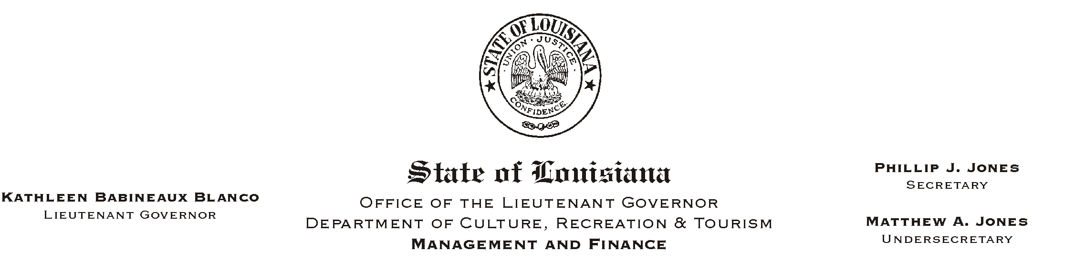

TO: Lt. Governor, Secretary, Undersecretary, Assistant Secretaries, Deputy Assistant Secretaries, Program Managers

FROM: Mary F. Ginn
Human Resources Director

SUBJECT: New Direct Deposit Enrollment Authorization Forms
Please Post and Circulate

On the new ISIS HR system, employees will be able to have their net pay directly deposited into a maximum of four bank accounts. The Amain bank@ record for those employees on direct deposit will indicate the primary account to which an employee=s net pay, less any amounts going to Aother banks@, will be deposited. An employee can also have three Aother bank@ (secondary) accounts.
HUMAN RESOURCE MEMORANDUM NO. 01-021

The Direct Deposit Authorization Form (UPR/F45) has been revised to accommodate these changes. There are now two new forms. The first form, OSUP/F12A, is to be used to record the Amain bank@ (primary) account information. Each employee will have only one of these forms. The second form, OSUP/F12B, is to be used to record the Aother bank@ (secondary account) information. For each secondary account the employee should indicate a fixed dollar amount or percentage of the net pay to go into the account. An employee could possibly have three of these forms if he/she chooses to have money disbursed to three Aother bank@ accounts.

Offices should replace the old direct deposit form with attached copies of the new forms. Please make copies of the attached forms or print the forms from the Office of State Uniform Payroll website at http://www.state.la.us/osup/osup.htm.

If there are any questions, please call the Human Resources office at (225) 342-1675.

Attachments

