March 16, 2001
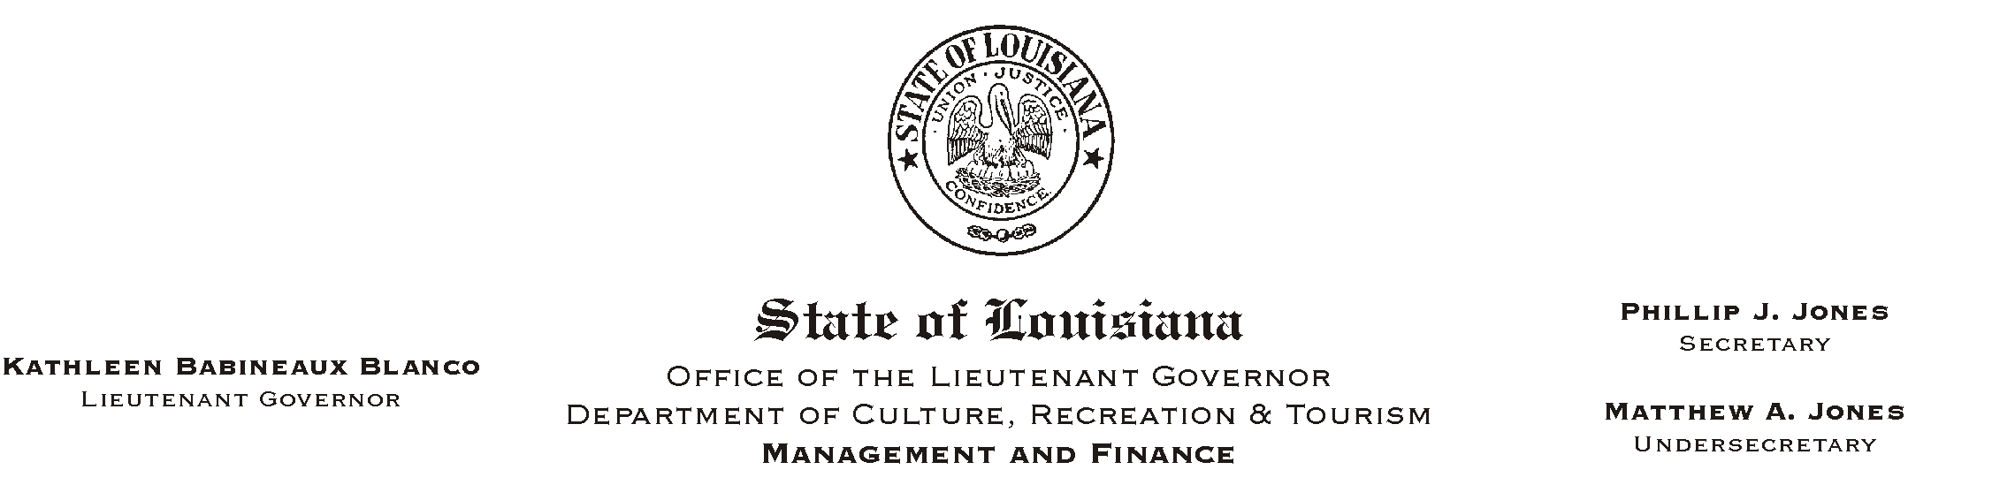

TO: Lt. Governor, Secretary, Undersecretary, Assistant Secretaries, Deputy Assistant Secretaries, Program Managers

FROM: Mary F. Ginn
Human Resources Director

SUBJECT: Employment Background Checks
Please Post and Circulate

In the past, the Department of State Civil Service routinely screened appointees to identify individuals who had been barred or previously dismissed from state service. Since this check was not made until the appointment was processed, the employee was on board before the check was made.
HUMAN RESOURCE MEMORANDUM NO. 01-022

Civil Service has enabled state departments to make these background checks before the applicant goes to work. New options have been added to the OPEN system that allow human resources offices to quickly check an applicant=s separation history, including the type of each separation. This history will also show departments when an applicant has been barred from state employment by the Director or the Civil Service Commission. An applicant who is barred cannot be hired.

In order to effectively utilize this feature, managers and supervisors should contact human resources when checking an applicant=s references and previous employers. We only need the applicant=s Social Security number to check the applicant=s history in the OPEN system. This quick and simple verification can save this department from investing orientation and training resources in unsuitable appointees.

Civil Service Rules do not forbid hiring people who were involuntarily dismissed from state service; but we strongly urge you to get the facts and circumstances surrounding the separation and to discuss the situation with the former agency and the applicant before hiring your new employee.

If there are any questions, please call the Human Resources Office at (225) 342-1675.

