March 20, 2000
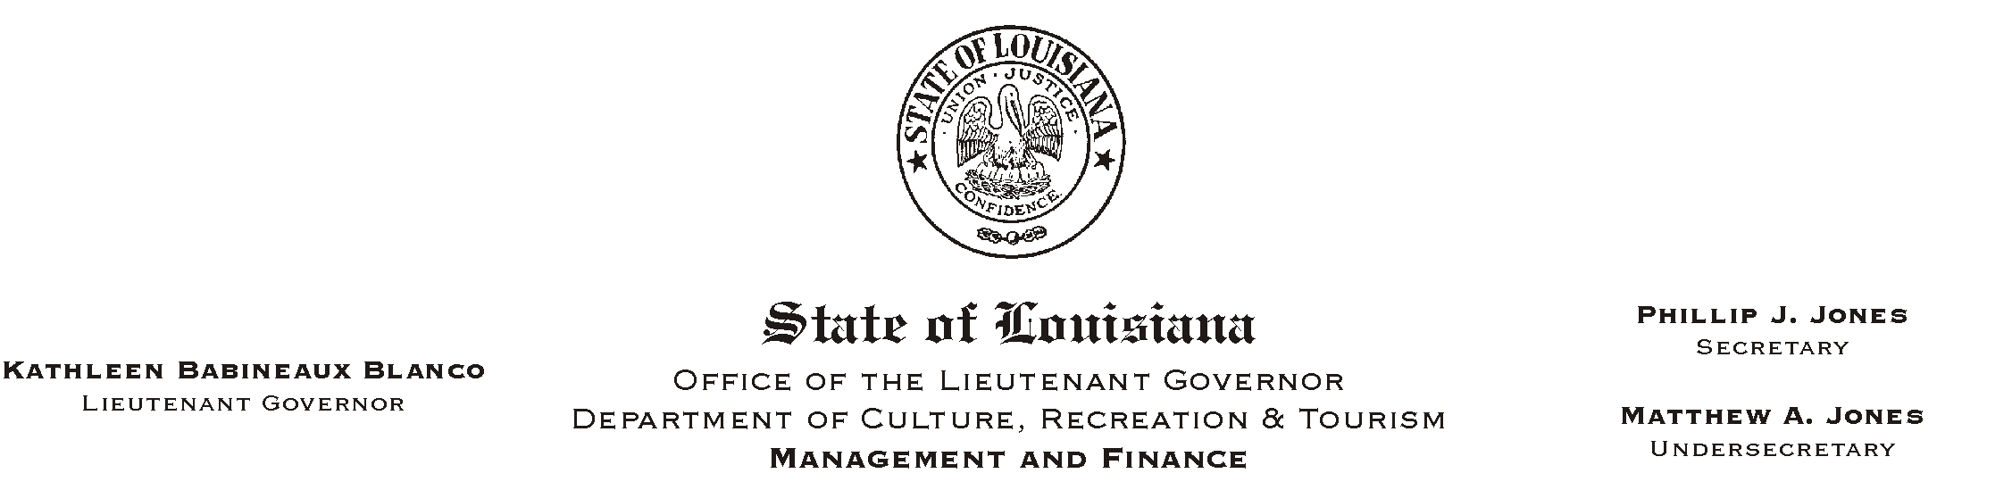

TO: Lt. Governor, Secretary, Undersecretary, Assistant Secretaries, Deputy Assistant Secretaries, Program Managers

FROM: Mary F. Ginn
Human Resources Director

SUBJECT: 2000 LASERS Member Account Statements
Please Post and Circulate

Enclosed are the 2000 Louisiana State Employees= Retirement System (LASERS) Member Account Statements and explanation sheets for distribution to the employees in your office. Copies will be filed in the official personnel file maintained in our office.

All questions and/or corrections relative to the statements should be directed to the Human Resources Office at (225) 342-0880. We will review the inquiries and forward all corrections and questions received to the retirement system.

Thank you for your cooperation and assistance.

Enclosures

NOTE: For more information on LASERS, including the Membership Handbook, check their web site at www.lasers.state.la.us.
HUMAN RESOURCE MEMORANDUM NO. 01-024

