April 6, 2001
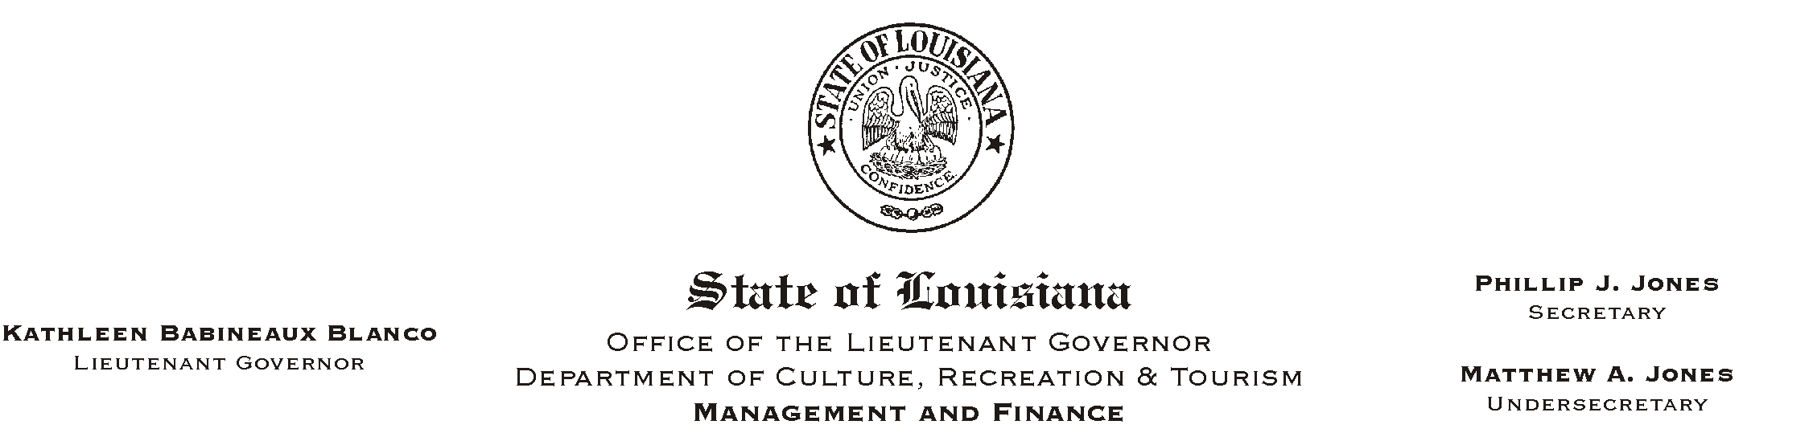

TO: Lt. Governor, Secretary, Undersecretary, Assistant Secretaries, Deputy Assistant Secretaries, Program Managers

FROM: Mary F. Ginn
Human Resources Director

SUBJECT: A Lunch & Learn Workshop - Workplace Violence
Please Post and Circulate
(Another in our series of informational meetings on health and safety)
Violence in the Workplace-The Calm Before the Storm
Corporal Riley Harbor, Baton Rouge Police Department
Tuesday, April 17, 2001
11:30 a.m. - 1:00 p.m.
Seminar Center, State Library

You are invited to a Lunch & Learn Workshop presented by Corporal Riley Harbor of the Baton Rouge Police Department, Community Resource Office. According to the Bureau of Labor Statistics, homicide is the number two cause of death in the workplace; number one for women. Recent studies suggest that one out of every four employees was attacked, threatened or harassed at work in the last year. Information presented in this workshop can teach you how to identify the different types of violence, their causes, how you can protect yourself and your co-workers, and why reporting workplace violence is extremely important.

We will plan to eat lunch at 11:30 and the presentation will begin at 12 noon. Employees can order a gourmet box lunch from AUnique Cuisine@ or bring their own lunch. Those who wish to attend the presentation only should still register and arrive no later 12 noon.

HUMAN RESOURCE MEMORANDUM NO. 01-027
This workshop will also serve as a safety meeting. Please complete the attached registration form and submit to the Human Resources Office no later than Monday, April 16, 2001. Those interested can also register on-line on AChannel Z.@
Please Post and Circulate

Attachment

