April 17, 2001
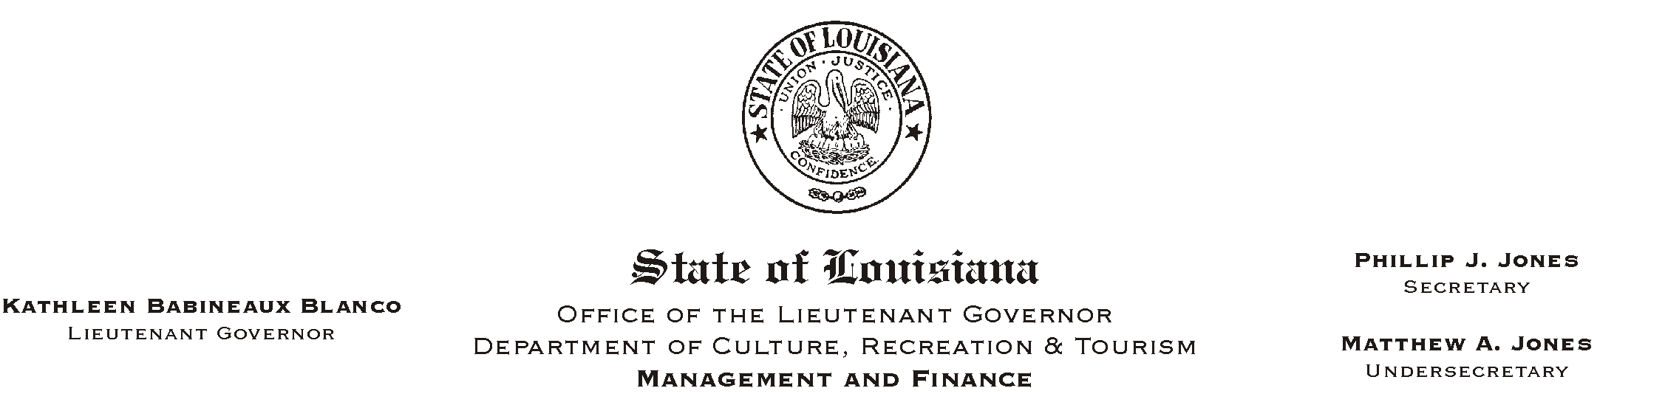

TO: Lt. Governor, Secretary, Undersecretary, Assistant Secretaries, Deputy Assistant Secretaries, Program Managers

FROM: Mary F. Ginn
Human Resources Director

SUBJECT: April 26, 2001BATake Our Daughters to Work@ Day
Please Post and Circulate

National Take Our Daughters to Work Day, the fourth Thursday in April, is an opportunity to reach out to a young girl in your life and make her feel visible, valued, and heard. The Lieutenant Governor=s Office and the Department of Culture Recreation & Tourism are encouraging employees to take their daughters and other girls in their lives to work for the day.
HUMAN RESOURCE MEMORANDUM NO. 01-029

The Ms. Foundation for Women created Take Our Daughters to Work Day in 1993. Since then, millions of girls have participated in the program and are now entering the workforce secure and confident in themselves. Those interested in more information about this nation-wide program can visit the Take Our Daughters to Work website at www.takeourdaughterstowork.org.

Girls and their sponsors are invited for lunch with the Lieutenant Governor at the Pentagon Barracks. The lunch will begin at 12:00. Lieutenant Governor Blanco will talk about the positive role models in her life and how she was able to achieve success in a non-traditional career field. Please RSVP to the Human Resources Office at 342-1675 by April 20 so we know approximately how many girls and sponsors will attend the luncheon.

Since school policies vary, employees should verify with school officials that April 26, 2001, will be considered an excused absence for participating students.

Ask a girl in your lifeBa daughter, granddaughter, niece, neighbor or friendBif she wants to go to work with you on Thursday, April 26, 2001. By helping her join the next generation of women in the workforce, you can help a special girl in your life to change the world.

