April 26, 2001
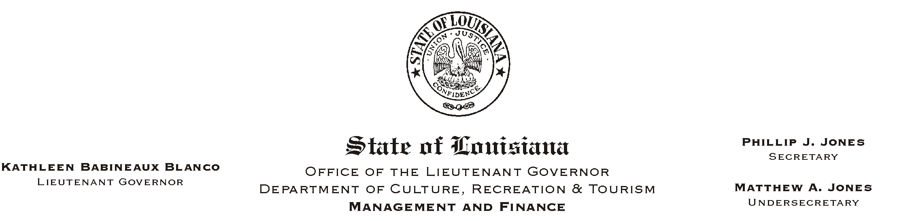
TO: Lt. Governor, Secretary, Undersecretary, Assistant Secretaries, Deputy Assistant Secretaries, Program Managers

FROM: Mary F. Ginn
Human Resources Director

SUBJECT: Flexible Benefits Eligibility Reports/Changes in Miscellaneous Insurance Products Available for Payroll Deduction
Please Post and Circulate

Enclosed are the Employee Flexible Benefits Eligibility Reports for distribution to employees in your office. The reports include employees who are both enrolled and not enrolled in the Flexible Benefits Plan. During Annual Enrollment, employees who are currently in the Flexible Benefits Plan are not required to complete a new form except under the following circumstances:
HUMAN RESOURCE MEMORANDUM NO. 01-030

- Employees participating in the Flexible Benefits Plan want to stop participation.
- Employees who want to join the Dependent Care Flexible Spending Account.
- Employees who want to re-enroll in the Dependent Care Flexible Spending Account.

Employees wanting to join the Flexible Benefits Plan or make any of the above changes must obtain and complete a new State of Louisiana Flexible Benefits Plan Enrollment/Stop Form (rev.2001). All new forms must be submitted to Human Resources by May 25, 2001.

Also enclosed is a memorandum from the Office of State Uniform Payroll (OSUP) listing the miscellaneous vendors and products that will no longer be available for payroll deduction after July 1, 2001. Please distribute this memorandum with the Flexible Benefits Eligibility reports. Although unclassified wage employees are not eligible for regular benefits, some of these employees are enrolled in a miscellaneous insurance plan. Please ensure that these employees are also aware of the changes.

If there are any questions please call the Human Resources Office at (225) 342-1675.

Attachments

