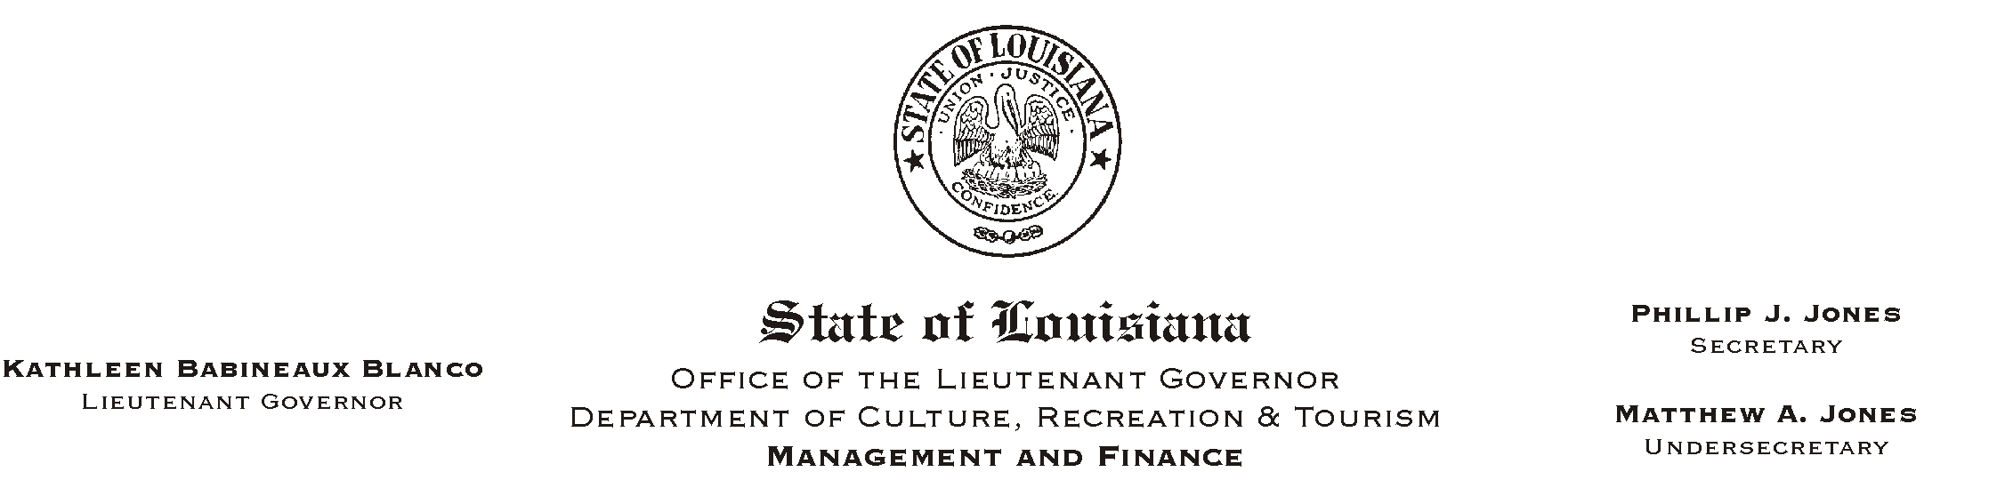
HUMAN RESOURCE MEMORANDUM NO. 01-033

May 7, 2001

TO: Lt. Governor, Secretary, Undersecretary, Assistant Secretaries, Deputy Assistant Secretaries, Program Managers

FROM: Mary F. Ginn
Human Resources Director

SUBJECT: State Employee Recognition Reception

Governor Mike Foster has proclaimed May 9, 2001 State Employee Recognition Day as a part of the nationwide Public Service Recognition Week which is the week of May 7, 2001 until May 11, 2001. This week and day was established to make the public aware of the services that public employees provide. The week has also been established to recognize and thank employees who dedicate themselves to public service and the hard work and effort they put forth to serve the needs of citizens. We have attached a copy of the Governor’s Proclamation for your review.

On Friday, May 11, 2001, Lieutenant Governor Kathleen Blanco and Secretary Phillip Jones will thank all employees for their hard work and dedication to the Department and to the State of the Louisiana by hosting a reception. The reception will be held from 2:30 p.m. until 3:30 p.m. at the State Library Conference Center. Light refreshments will be served.

If you plan to attend, please contact the Human Resources Office at (225) 342-0880 or e-mail Heather Sherlock at hsherlock@crt.state.la.us.

Attachment

Please Post and Circulate

