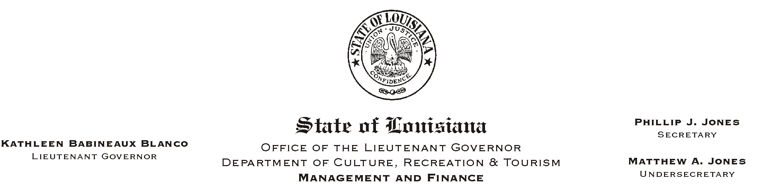
HUMAN RESOURCE MEMORANDUM NO. 01-034
May 7, 2001
Please Post and Circulate

TO: Lt. Governor, Secretary, Undersecretary, Assistant Secretaries, Deputy Assistant Secretaries, Program Managers

FROM: Mary F. Ginn
Human Resources Director

SUBJECT: Insurance Representatives to Speak at ABrown Bag@ Lunch

Representatives from Blue Cross/Blue Shield of Louisiana and Physicians Mutual Insurance Company will be in the State Library Seminar Center from 11:30 a.m. until 12:30 p.m. on Friday, May 11, 2001.

Blue Cross/Blue Shield and Physicians Mutual are two companies that offer health insurance policies on an individual basis. Beginning at 11:30 a.m., representatives from each company will make short presentations on some of the plans available through their companies. After the presentations, the representatives will be available to answer questions.

This is an opportunity for employees who are not eligible or who do not want to participate in the State Employees= Group Benefits Program to find out information about other health insurance plans. Employees should be aware that the state pays a percentage of the health insurance premiums for policies offered by State Group. The state will not pay any portion of the premiums for any of the policies presented at this meeting. Plans offered at this meeting will not be eligible for payment through direct payroll deduction or participation in the State of Louisiana Flexible Benefits Program.

Employees are invited to bring their lunch to the presentation since we will not be ordering lunch.

If there any questions, please call the Human Resources Office at (225) 342-0880.

