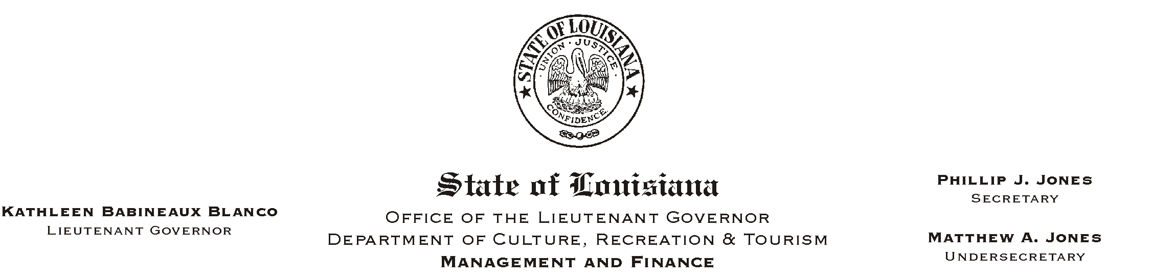
HUMAN RESOURCE MEMORANDUM NO. 01-035

May 16, 2001

TO: Lt. Governor, Secretary, Undersecretary, Assistant Secretaries, Deputy Assistant Secretaries, Program Managers

FROM: Mary F. Ginn
Human Resources Director

SUBJECT: A Lunch and Learn Workshop – “Performance Reviews, Discipline and Termination”

Performance Reviews, Discipline and Termination

Eric Miller, Attorney-at-Law
Tuesday, May 29, 2001
11:30 a.m. – 1:00 p.m.
Seminar Center, State Library

Appointing Authorities, Managers and Supervisors are invited to a Lunch and Learn Workshop presented by Eric Miller, Attorney-at-Law, on May 29, 2001 from 11:30 a.m. until 1:00 p.m. in the Seminar Center at the State Library. Mr. Miller will discuss how to document performance and conduct performance appraisals, document disciplinary infractions, and provide tips on handling terminations and exit interviews.

We will plan to eat lunch at 11:30 a.m. and the seminar will begin at 12:00 noon. Employees may order lunch from Ami’s Catering or bring their own lunch. Those who wish to attend the presentation only should still register and arrive no later than 12:00 noon.

Please complete the attached registration form and submit it to the Human Resources Office no later than noon on Friday, May 25, 2001. Those interested can also register online via “Channel Z.”

Attachment

Please Post and Circulate

A ALUNCH AND LEARN@ WORKSHOP
Performance Reviews, Discipline and Terminations
Mr. Eric Miller, Attorney-at-Law
May 29, 2001, 11:30 a.m. - 1:00 p.m.
Seminar Center, State Library
REGISTRATION FORM

Please Print:

NAME _______________________________________________________________________

DEPARTMENT_________________________________ PHONE #_____________________

_____ INCLUDE ME IN THE BOX LUNCH
*** Note: If you are unable to attend after making a reservation and fail to notify us, please understand that we must consider this registration a guarantee for your payment.
Lunch Choice:
_____Grilled Chicken Salad: Grilled chicken with roasted pecans, artichokes and sun-dried tomatoes mixed with pesto vinaigrette on a bed of fresh lettuce. Served with crackers, fruit, a cookie and a soft drink.
_____Traditional Club Sandwich: Smoked turkey, ham, bacon and smoked cheddar on toasted white bread. Served with pasta salad, fruit, dessert and a soft drink.
_____Smoked Turkey Sandwich: Thinly sliced smoked turkey breast dressed and served on a croissant. Served with pasta salad, fruit, dessert and a soft drink.
_____De La Ronde Wrap It Up: Jerk Chicken with grilled onions, roasted peppers and a black bean sour cream spread rolled in a soft tortilla. Served with pasta salad, fruit, dessert and a soft drink.

Payment Choice:
_____Check for $13.00 made payable to Ami’s Catering is attached.
_____I will pay at the meeting.

OR
_____ I WILL ATTEND THE PRESENTATION BUT WILL NOT PARTICIPATE IN LUNCH.
Signatures:

EMPLOYEE__________________________________________ DATE__________________

SUPERVISOR________________________________________ DATE__________________

