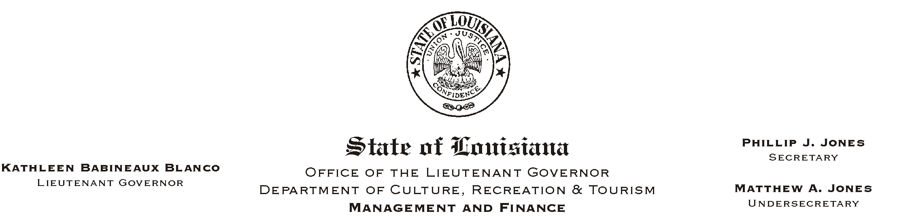
HUMAN RESOURCE MEMORANDUM NO. 01B036
May 15, 2001
Please Post and Circulate

TO: Lt. Governor, Secretary, Undersecretary, Assistant Secretaries, Deputy Assistant Secretaries, Program Managers

FROM: Mary F. Ginn
Human Resources Director

SUBJECT: Memorial Day Holiday/Payroll Deadline

Governor Foster has proclaimed Monday, May 28, 2001, a legal holiday for State workers in observance of National Memorial Day.

Because of this holiday, the Human Resources Office will need all payroll information for the pay period ending May 27, 2001, no later than Wednesday, May 23, 2001. This deadline also applies to employees who need to update their payroll or benefits information (i.e., direct deposit authorization, insurance, addresses, etc.) during this pay period.

If you have any questions, please call the Human Resources Office at (225) 342-0880.

