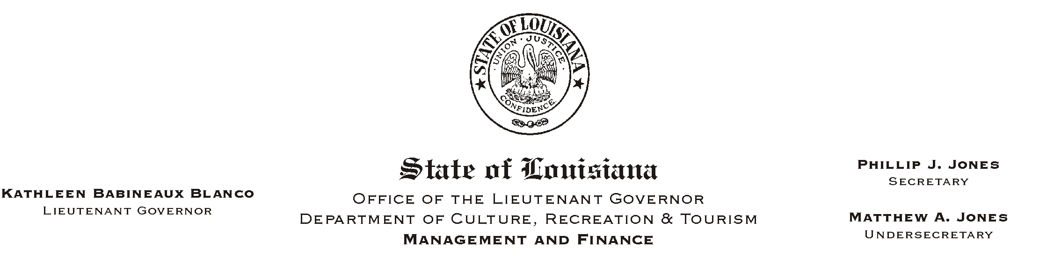
HUMAN RESOURCE MEMORANDUM NO. 01-039
May 21, 2001
Please Post and Circulate

TO: Lt. Governor, Secretary, Undersecretary, Assistant Secretaries, Deputy Assistant Secretaries, Program Managers

FROM: Mary F. Ginn
Human Resources Director

SUBJECT: Special Offers for Jazzland Tickets

Employees of this department have the opportunity to buy tickets to the Jazzland theme park in New Orleans at a discounted rate.

For a limited time, employees can buy one ticket at the regular adult price and get one ticket free. To take advantage of this special offer, employees must purchase Jazzland tickets in advance via www.grouptickets.com, or call 1-866-GROUPTX (476-8789). The promotional code is JAZZ630. Tickets purchased are valid all season, and there is no ticket limit. This offer expires June 30, 2001.

Employees can also obtain a Jazzland Thrill Club Card. With a Thrill Club Card you save between $4.00 and $8.00 (depending on the date) on the regular adult admission price. If you are interested in getting a Thrill Club Card, please contact Human Resources.

Please distribute the attached flyers to all interested employees. If you have any questions, please call the Human Resources Office at (225) 342-0880.

Attachments

