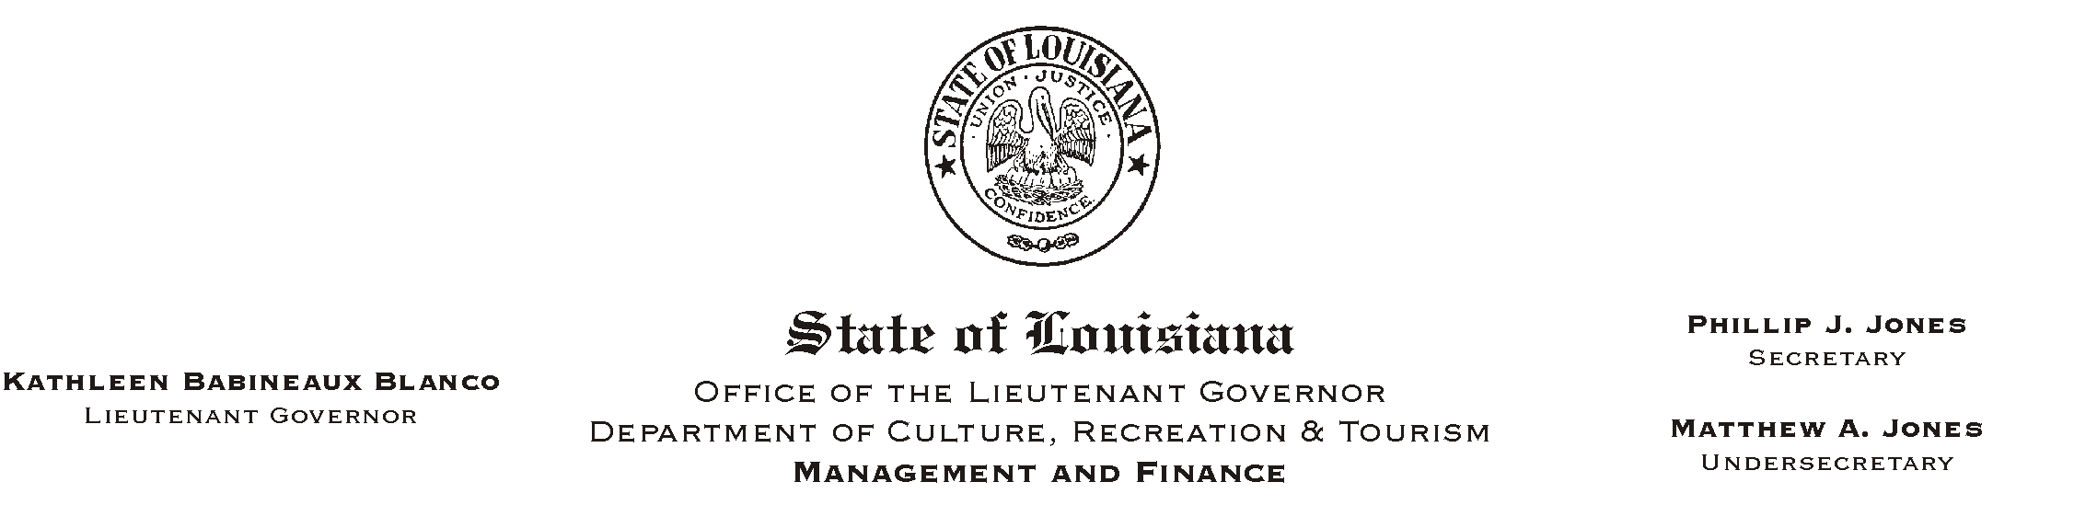
HUMAN RESOURCE MEMORANDUM NO. 01-041

June 12, 2001
Please Post and Circulate

TO: Lt. Governor, Secretary, Undersecretary, Assistant Secretaries, Deputy Assistant Secretaries, Program Managers

FROM: Mary F. Ginn
Human Resources Director

SUBJECT: Miscellaneous Vendors/Products Approved for Payroll Deduction

Employees were notified in HR Memo No. 01-030 of the miscellaneous vendors and products that would no longer be available through direct payroll deduction. Due to legislative action, all miscellaneous products available before July 1, 2001, will continue to be eligible for direct payroll deduction.

Enclosed is a memorandum from the Office of State Uniform Payroll (OSUP) listing the miscellaneous vendors and products that will be available for payroll deduction after July 1, 2001.

If you have questions, please call the Human Resources Office at (225) 342-1675.

Attachment

