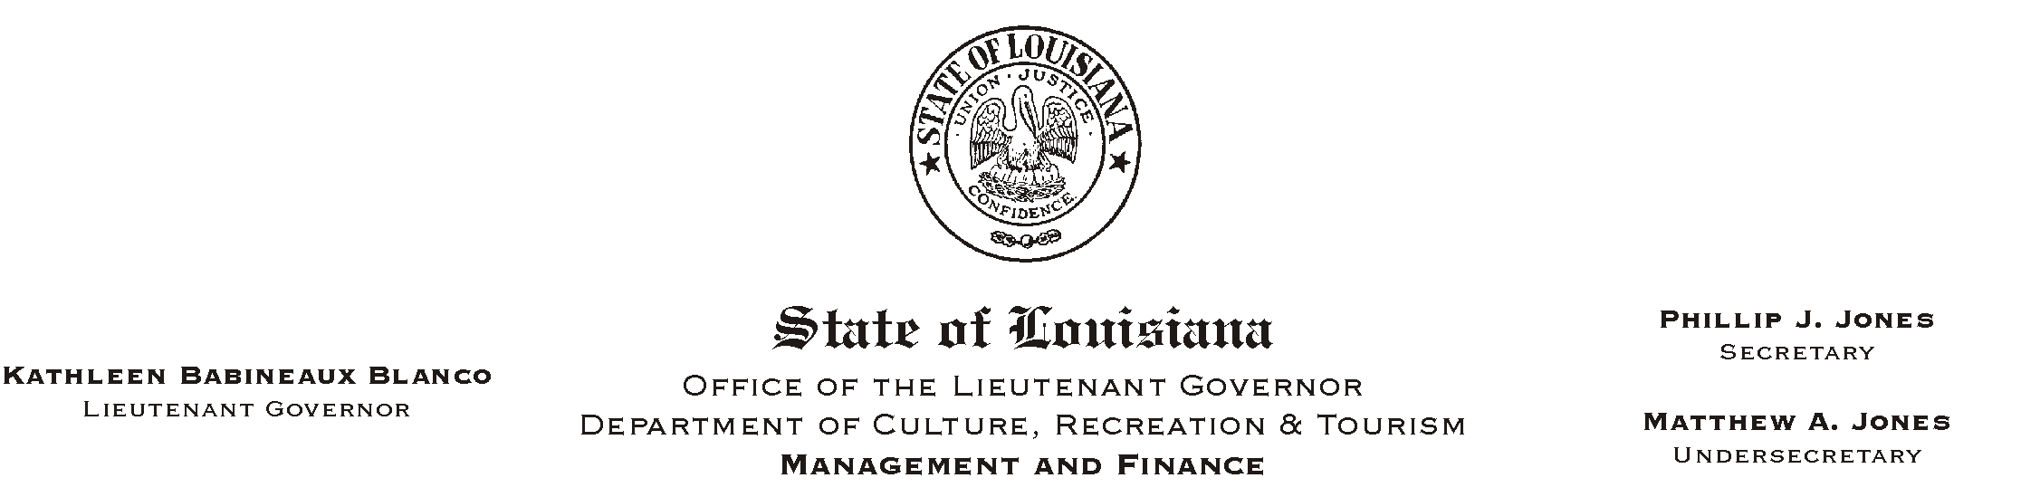
HUMAN RESOURCE MEMORANDUM NO. 01-043
June 26, 2001
Please Post and Circulate

TO: Lt. Governor, Secretary, Undersecretary, Assistant Secretaries, Deputy Assistant Secretaries, Program Managers

FROM: Mary F. Ginn
Human Resources Director

SUBJECT: LASERS Board of Trustees Election

The Louisiana State Employees= Retirement System (LASERS) has initiated the 2001 Board of Trustees election process. Three active trustee representatives and one retiree trustee are up for election for four-year terms. Active incumbents are Cynthia Bridges and Virginia Burton, both from Baton Rouge and the Department of Revenue, and Frank Jobert from New Orleans and the Department of Corrections. The retiree incumbent is Louis Quinn from Baton Rouge.

The nomination period is June 12 through July 10, 2001. Voting takes place from September 28 to October 26, 2001, with the winning candidates being seated at the regular January 2002, Board meeting.

Enclosed is an Active Candidate packet for copying, posting and dissemination. Election information and active and retiree candidate packets also are available for downloading on the ABoard Election 2001" portion of the LASERS web site, http://www.lasers.state.la.us.

If you have questions, please call the Human Resources Office at (225) 342-1675.

Attachments

