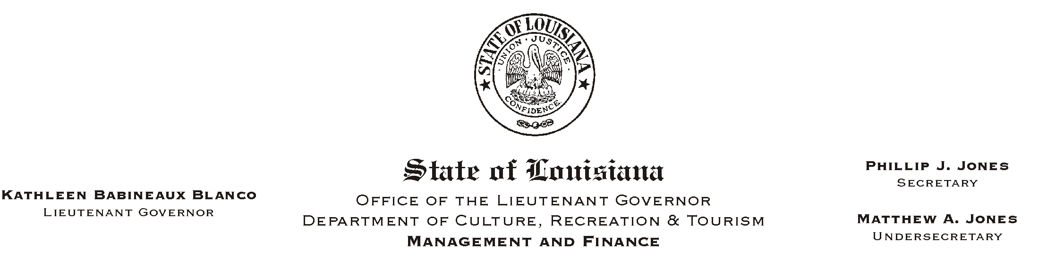
HUMAN RESOURCE MEMORANDUM NO. 01-048
July 11, 2001
Please Post and Circulate

TO: Lt. Governor, Secretary, Undersecretary, Assistant Secretaries, Deputy Assistant Secretaries, Program Managers

FROM: Mary F. Ginn
Human Resources Director

SUBJECT: Office of Group Benefits Drug Benefit Plan Changes

The following changes to the Group Benefits prescription drug plan will be implemented effective August 1, 2001:

- The coinsurance maximum will be reduced from $50 to $40.

- After a plan member reaches $500 in out-of-pocket pharmaceutical expenses between July 1, 2001 and December 31, 2001, the plan member will be charged a $15 copay for each brand name drug purchase and there will be no copayment for generic drug purchases.

- On and after January 1, 2002, plan members will be required to expend $1,000 each year before receiving brand name drugs for a $15 copay and generic drugs with no copayment.

The above changes affect members of the Group Benefits EPO and PPO health insurance plans and the AmCare HMO. Members of the Ochsner HMO are not affected by theses changes. Ochsner Health Plan has a 50/50 co-insurance prescription drug program with the maximum copayment being $50 per prescription.

