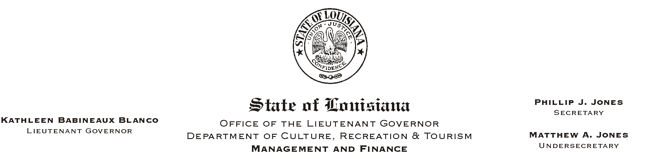
HUMAN RESOURCE MEMORANDUM NO. 01-049
July 11, 2001
Please Post and Circulate

TO: Lt. Governor, Secretary, Undersecretary, Assistant Secretaries, Deputy Assistant Secretaries, Program Managers

FROM: Mary F. Ginn
Human Resources Director

SUBJECT: Our Lady of the Lake Signs with Group Benefits

Our Lady of the Lake Regional Medical Center in Baton Rouge has agreed to a contract with the Office of Group Benefits to be a service provider for the EPO and PPO plans, effective July 1, 2001 (Our Lady of the Lake is already a provider for the Ochsner Health Plan).

Plan members can call Group Benefits= toll-free at 1-800-272-8451 (925-6625 in the Baton Rouge calling area) for more information about providers in their area.

NOTE: Information on the Office of Group Benefits, including the Summary of Benefits, Newsletter, HMOs, PPO and EPO Directories, Life Insurance, Frequently Asked Questions (FAQ), etc., is always available on their web site located at http://www.groupbenefits.org/.

