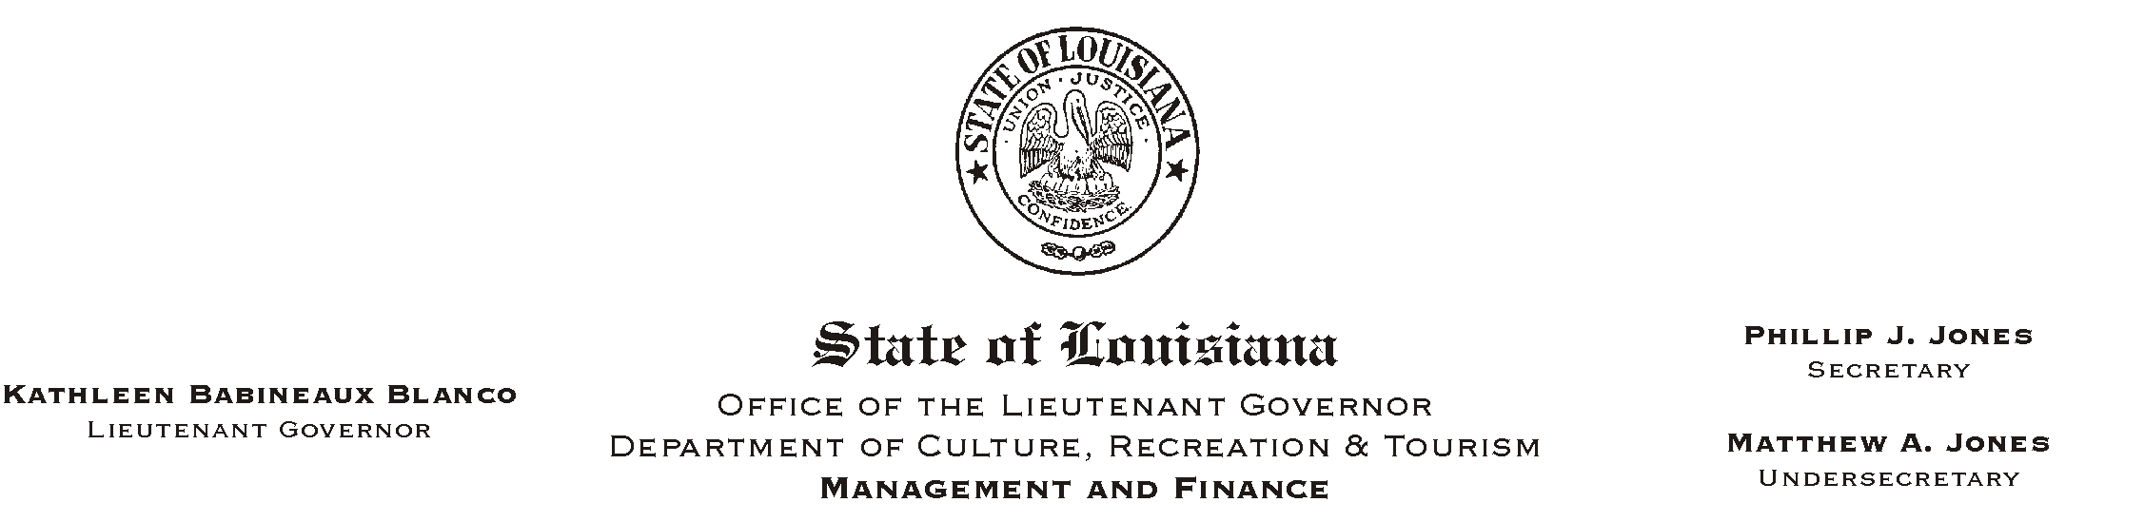
HUMAN RESOURCE MEMORANDUM NO. 01-050
July 17, 2001
Please Post and Circulate

TO: All Lieutenant Governor and CRT Employees

FROM: Mary F. Ginn
Human Resources Director

SUBJECT: Elimination of Direct Deposit Notices/Employee Self Service

Direct deposit notices will no longer be produced and mailed to employees. The pay statement for July 13, 2001 was the last to be printed and sent to employees. To view your direct deposit amount, leave balances, employee deductions, etc., you will need to access Employee Self Service (ESS) through the Internet.
The address for ESS is http://www.state.la.us/isis/ess. You can also access ESS via the INFO Louisiana home page by using the AFor State Employees@ link at the bottom left of the page. Either path will open the ESS application and point you to the on-line instructions that should be reviewed prior to actual use of ESS.
Your log-on ID is your eight digit personnel number found in the upper left area of your pay statement. To log-on to ESS, you must type the letter AP@ in front of this number. Your initial password is four characters and can be found on your prior pay statements.

Access to Employee Self Service is password protected. The Office of Statewide Information Systems (OSIS) is working to put ESS on an encrypted system. At that time more information should also be available on the pay statement. When ESS is on an encrypted system, you will be able to access it through CRT=s AChannel Z@ website via the Human Resources link.

If you encounter problems or need additional information, please contact the Human Resources Office at 342-0880.

