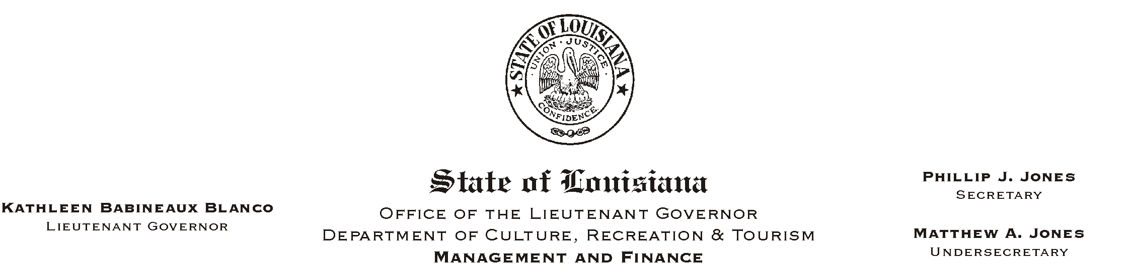
HUMAN RESOURCE MEMORANDUM NO. 01-051
July 17, 2001
Please Post and Circulate

TO: Lt. Governor, Secretary, Undersecretary, Assistant Secretaries, Deputy Assistant Secretaries, Program Managers

FROM: Mary F. Ginn
Human Resources Director

SUBJECT: Employee Self Service (ESS)

The Division of Administration will no longer print and mail to employees direct deposit pay statements.

In order to view direct deposit amounts, leave balances, deductions, etc., employees will have to access Employee Self Service (ESS) via the Internet. Some offices may be equipped to provide employees with Internet access. For some CRT locations, and for employees with irregular work schedules, this may be impossible.

It is the responsibility of our department to assure that all employees have access to their pay information.

Offices have the capability of providing employees with a Apaper@ stub. Timekeepers can process the ISIS HR report ZP114 that contains the same information that is shown on the current pay statement. Offices that print this information for their employees should take precautions to protect the privacy rights of their employees.

HR Memo 01-050 details how to reach the ESS web site and how to obtain the log-on ID and password. Ensure that all employees receive a copy of this memorandum. Access to ESS is password protected. The Office of Statewide Information Systems is working to put ESS on an encrypted system. At that time, more information should also be available on the pay statements.
If you have any questions, please call the Human Resources Office at (225) 342-0880.

Please Post and Circulate

