HUMAN RESOURCE MEMORANDUM NO. 01-047
July 24, 2001
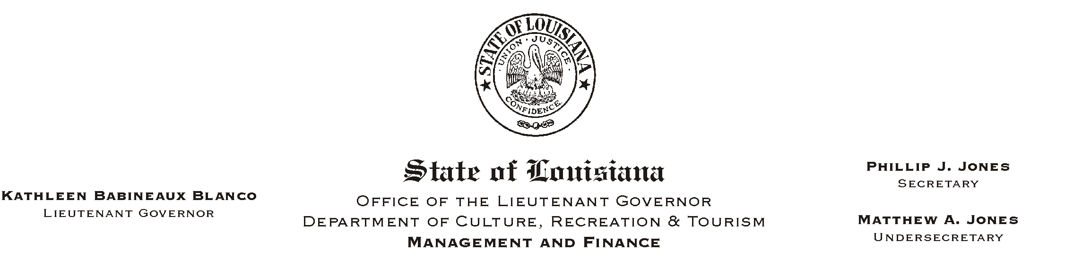

TO: Lt. Governor, Secretary, Undersecretary, Assistant Secretaries, Deputy Assistant Secretaries, Program Managers

FROM: Mary F. Ginn
Human Resources Director

SUBJECT: New Hire Checklist Revised

Enclosed are copies of the revised New Hire Checklist (07/01) to be used for orientation of new employees. Please note the following additions and/or changes and begin immediately using the updated forms:
HUMAN RESOURCE MEMORANDUM NO. 01-056

- Acknowledgment of Physical Condition and Pre-Existing Condition Form: Employees hired after July 1, 2001, who wish to enroll in state-sponsored health insurance are subject to a pre-existing condition clause on themselves and any dependents they wish to cover. Any medical condition treated in the six months previous to a plan member=s effective date of coverage will be excluded from benefit payments and coverage for a period of one year.

- Insurance Portability Law Application: To be submitted with the health insurance enrollment information, this form lets an employee show that he/she was previously covered by a health insurance plan, thus decreasing or eliminating the pre-existing condition limitation.

- Overview of DCRT: Updated for year 2001-2002.

- Prudential Life Insurance Enrollment Kit: Employees should complete the enrollment form and indicate whether they want life insurance coverage or wish to waive coverage.

If you have any questions, please call the Human Resources Office at (225) 342-0880.

Attachments

