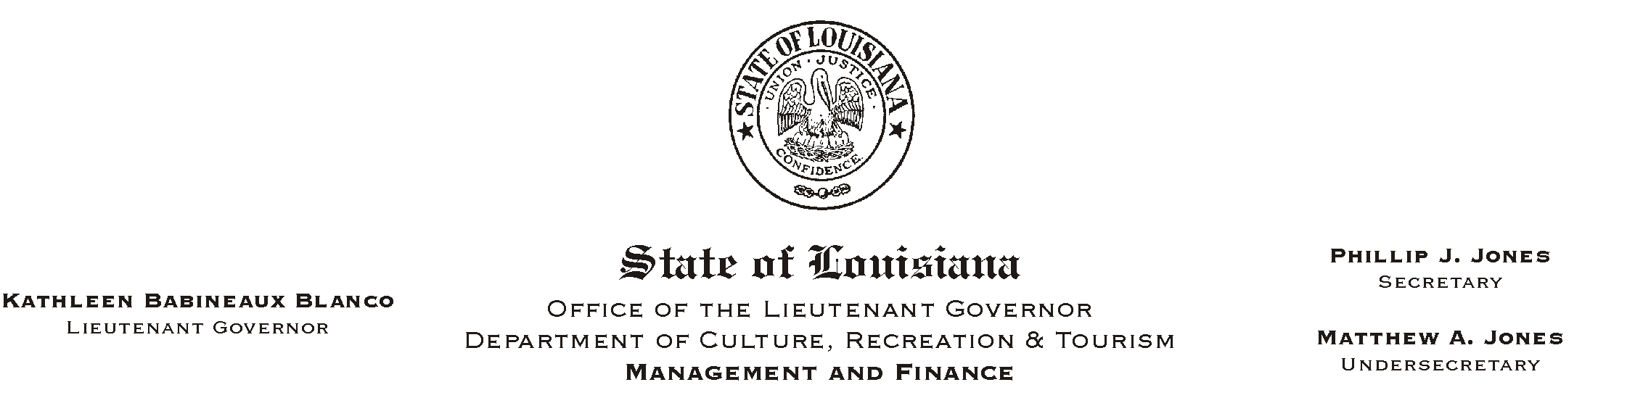
HUMAN RESOURCES MEMORANDUM NO. 01-066
August 29, 2001
Please Post and Circulate

TO: All Employees of the Lt. Governor=s Office and the Department of Culture, Recreation & Tourism

FROM: Mary F. Ginn
Human Resources Director

SUBJECT: Employee Self Service (ESS)

The Division of Administration will temporarily resume printing and mailing direct deposit notices beginning with the September 7, 2001 pay date.

Since ESS was implemented, training issues as well as other concerns have continued to be expressed by some employees. The resumption of printing and mailing direct deposit notices is an interim measure while these issues and concerns are addressed.

If you have any questions, please contact the Human Resources Office at (225) 342-0880.

