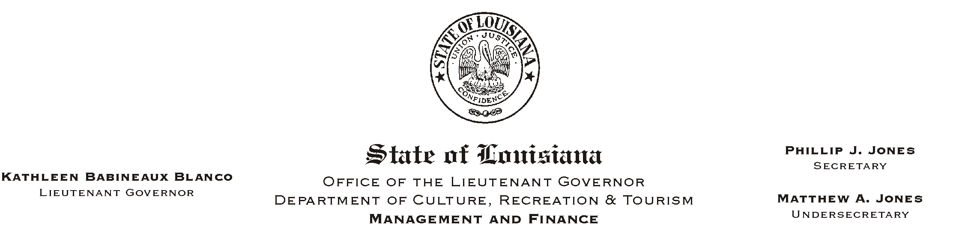
HUMAN RESOURCES MEMORANDUM NO. 01-068

September 7, 2001

TO: Lt. Governor, Secretary, Undersecretary, Assistant Secretaries, Deputy Assistant Secretaries, Program Managers

FROM: Mary F. Ginn
Human Resources Director

SUBJECT: Updated Drug Testing Collection Site List

Attached is an updated list of collection sites for drug testing.

Please note that the only changes were in Baton Rouge and New Orleans. In Baton Rouge, the collection site on Perkins Road (Callais Health System) was moved to a new location: 3333 Drusilla Lane. In New Orleans, the Micro-Tech Drug Testing and Consulting Center was moved from 8726 Chef Menteur Hwy., Suite 3 to 7045 Read Blvd., Suite 109.

If you have any questions, please contact the Human Resources Office at (225) 342-0880.

Attachment

Please Post and Circulate

