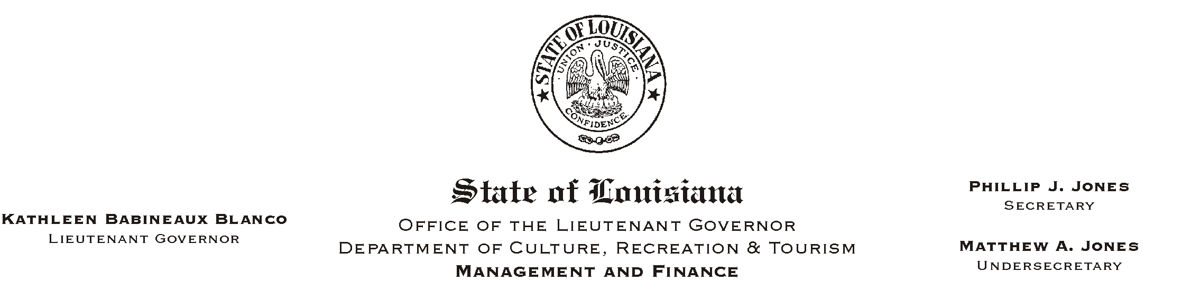
HUMAN RESOURCES MEMORANDUM NO. 01-069

September 7, 2001

TO: Lt. Governor, Secretary, Undersecretary, Assistant Secretaries, Deputy Assistant Secretaries, Program Managers

FROM: Mary F. Ginn
Human Resources Director

SUBJECT: Prohibited Political Activities

Attached is Civil Service General Circular No. 001449 regarding prohibited political activities for classified employees. Please be sure that all of your classified employees either have a copy of this Circular or have access to it.

If you have any questions, please call the Human Resources Office at (225) 342-0880.

Attachment

Please Post and Circulate

