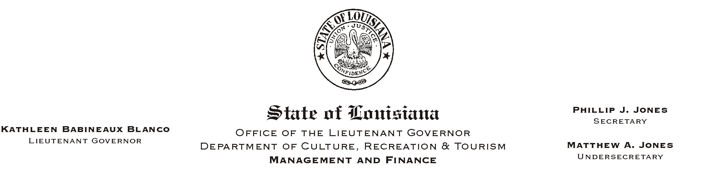
HUMAN RESOURCES MEMORANDUM NO. 01-072
October 2, 2001
Please Post and Circulate

TO: Lt. Governor, Secretary, Undersecretary, Assistant Secretaries, Deputy Assistant Secretaries, Program Managers

FROM: Mary F. Ginn
Human Resources Director

SUBJECT: Louisiana Library Connection

The State Library of Louisiana is offering a new service to all state employees and officials, the Louisiana Library Connection. This service provides an abundance of information from books, encyclopedias, magazines and newspapers via a variety of electronic sources. Employees can connect at home, work, or at any public library. Accessing the Louisiana Library Connection is simple:

1. Have your state or public library card ready
2. Connect to http://lalibcon.state.lib.la.us on the Internet
3. Follow the on-line instructions

Attached to this memo are a brochure and bookmark outlining the databases. Please make this material available to your employees. Employees without a library card can complete the attached application for a State Library card, or register on-line at http://www.state.lib.la.us/. Please send completed applications to:

State Library of Louisiana
User Services/Circulation
P.O. Box 131
Baton Rouge, LA 70821

Attachments

