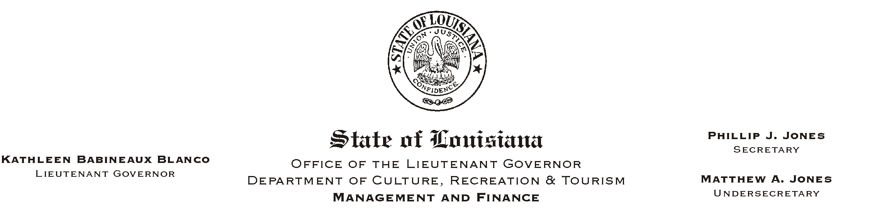
HUMAN RESOURCES MEMORANDUM NO. 01-073

October 4, 2001

TO: All Employees of the Lieutenant Governor and CRT Employees in the Capital Area Parishes of United Way

FROM: Mary F. Ginn
Human Resources Director

SUBJECT: 2001 United Way Campaign

It is that time again and we are gearing up for another successful United Way Campaign. The Capital Area held its annual kickoff on August 28 at the Centroplex.

Our campaign will begin on October 19, 2001 with a Jambalaya Kickoff, Bake Sale and Silent Auction and conclude on November 1, 2001 with all pledges and donations due to our office. Our traditional White Elephant Auction and lunch will be held on October 31 and "Casual Mondays" will begin on October 8. "Casual Day" participants will receive four "Casual Day" stickers for $6.00 and will be entitled to wear blue jeans on Monday October 8, 15, 22 and 29. Also, returning this year is the raffle drawing for the theme baskets. Each office will prepare a theme basket which will then be raffled off on the day of the White Elephant Auction.

We've set a goal of $9,000. What do we need for a successful campaign? First, we need you. Your participation is the most important thing. Next, we need your contributions in the form of pledges and participation in our campaign events. Our events are not only fun, but also the money you spend goes directly to local agencies and has a visible impact on our ten-parish community. Please join in when your United Way Committee representative asks for your assistance or participation. Watch for further details and notices to be posted.

It's important to remember that even though we raise money with the activities detailed above, the most money comes from your generous pledges. Attached are the pledge cards that will be used for this year's campaign. Please complete a pledge card and return it to the Human Resources Office no later than November 1, 2001.

Attachment

Please Post and Circulate

