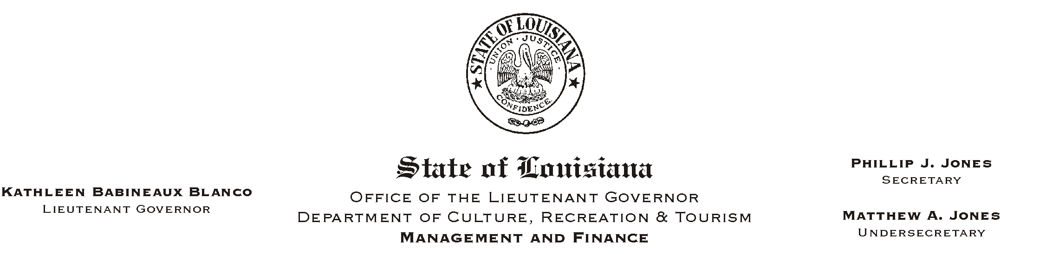
HUMAN RESOURCES MEMORANDUM NO. 01-076
October 30, 2001
Please Post and Circulate

TO: Lt. Governor, Secretary, Undersecretary, Assistant Secretaries, Deputy Assistant Secretaries, Program Managers

FROM: Mary F. Ginn
Human Resources Director

SUBJECT: Veterans= Day-Designated Holiday

Since Veterans= Day this year falls on a Sunday, the Governor has designated the following Monday, November 12, 2001, as a holiday in the State of Louisiana.

