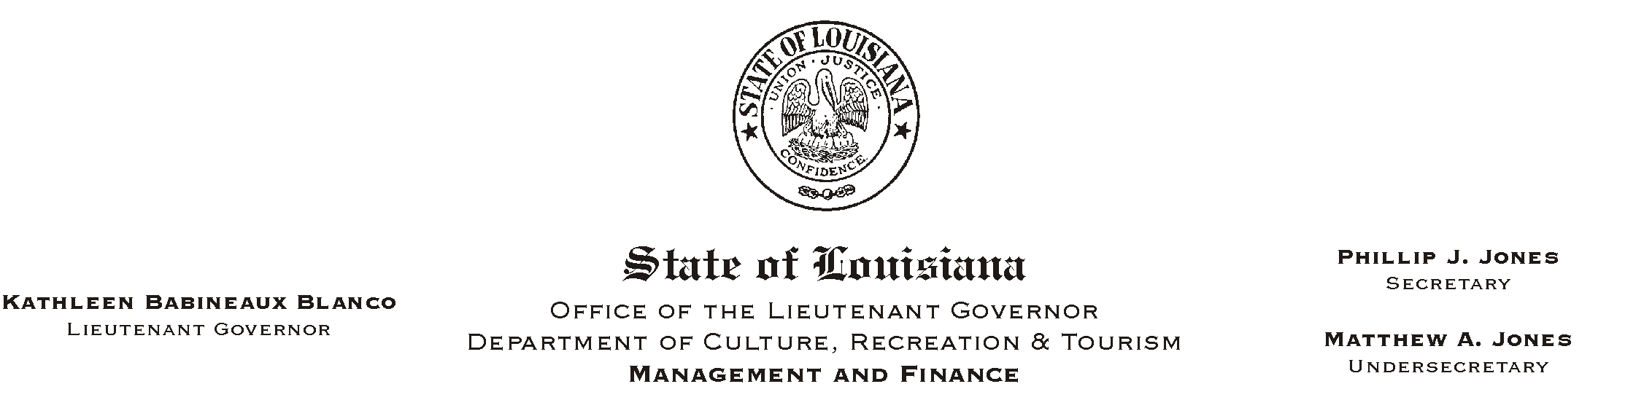
HUMAN RESOURCES MEMORANDUM NO. 01-078

November 21, 2001
Please Post and Circulate

TO: Lt. Governor, Secretary, Undersecretary, Assistant Secretaries, Deputy Assistant Secretaries, Program Managers

FROM: Mary F. Ginn
Human Resources Director

SUBJECT: Holiday Proclamations

The Governor has proclaimed Monday, December 24, 2001, a legal holiday in addition to the Christmas Day holiday, Tuesday, December 25, 2001.

The Governor has also proclaimed Monday, December 31, 2001, a legal holiday in conjunction with the New Year=s Day holiday, Tuesday, January 1, 2002.

If you have any questions, please call the Human Resources Office at (225) 342-0880.

