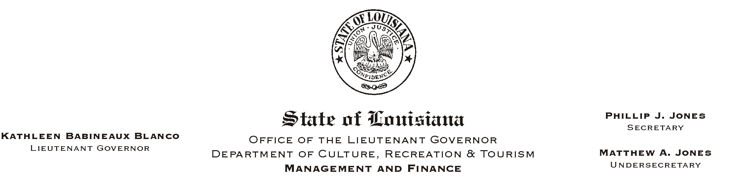
HUMAN RESOURCES MEMORANDUM NO. 01-079

December 17, 2001

TO: Lt. Governor, Secretary, Undersecretary, Assistant Secretaries, Deputy Assistant Secretaries, Program Managers

FROM: Mary F. Ginn
Human Resources Director

SUBJECT: New PPR Policy Imposes Penalties on Supervisors for Non-Compliance

Although the department as a whole has improved tremendously in conducting Performance Planning and Reviews (PPRs), statistics indicate that many supervisors are failing to plan and rate 100% of their employees as required. Therefore, it is necessary for the department to establish a policy imposing specific penalties on those who fail to comply with the rules. This policy, attached, is effective immediately.

In conjunction with the new policy, the “Merit Increase Consideration Form” has been modified and is also attached for your information. We will continue forwarding these forms to you in advance of employees’ anniversary dates. Please call the Human Resources Office if you have any questions.

Attachments

