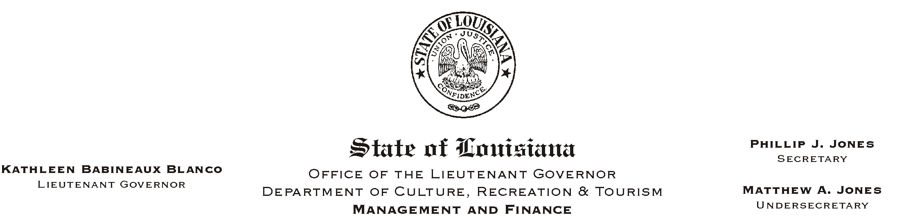
January 28, 2002
HUMAN RESOURCES MEMORANDUM NO. 02-008

TO: Lt. Governor, Secretary, Deputy Secretary, Undersecretary, Assistant Secretaries, Deputy Assistant Secretaries, Program Managers

FROM: Mary F. Ginn
Human Resources Director

SUBJECT: Military Reservists
Please Post and Circulate

Due to the military crisis facing our nation and the probability that some of our employees may be called to active service, we would like to remind managers and employees of the various laws and/or Civil Service rules which provide protection to military reservists who are called to active status.

Attached for your information are:

- Civil Service Rules regarding Military Leave
- Civil Service General Circular No. 001458 - Military Leave
- LASERS Liaison Memorandum No. 01-19 RE: Military Leave
- Office of Group Benefits Executive Policy 01-01 - Military Duty

Also attached is a form reservists should complete to clearly define their elected options at the earliest available time. We understand the call-up can often happen quickly and the employee may not have an opportunity to make these decisions once activated.

Please encourage your employees who are military reservists to contact the Human Resources Office if they have any questions concerning their entitlements and/or the options available to them.

Attachments
Please Post and Circulate

