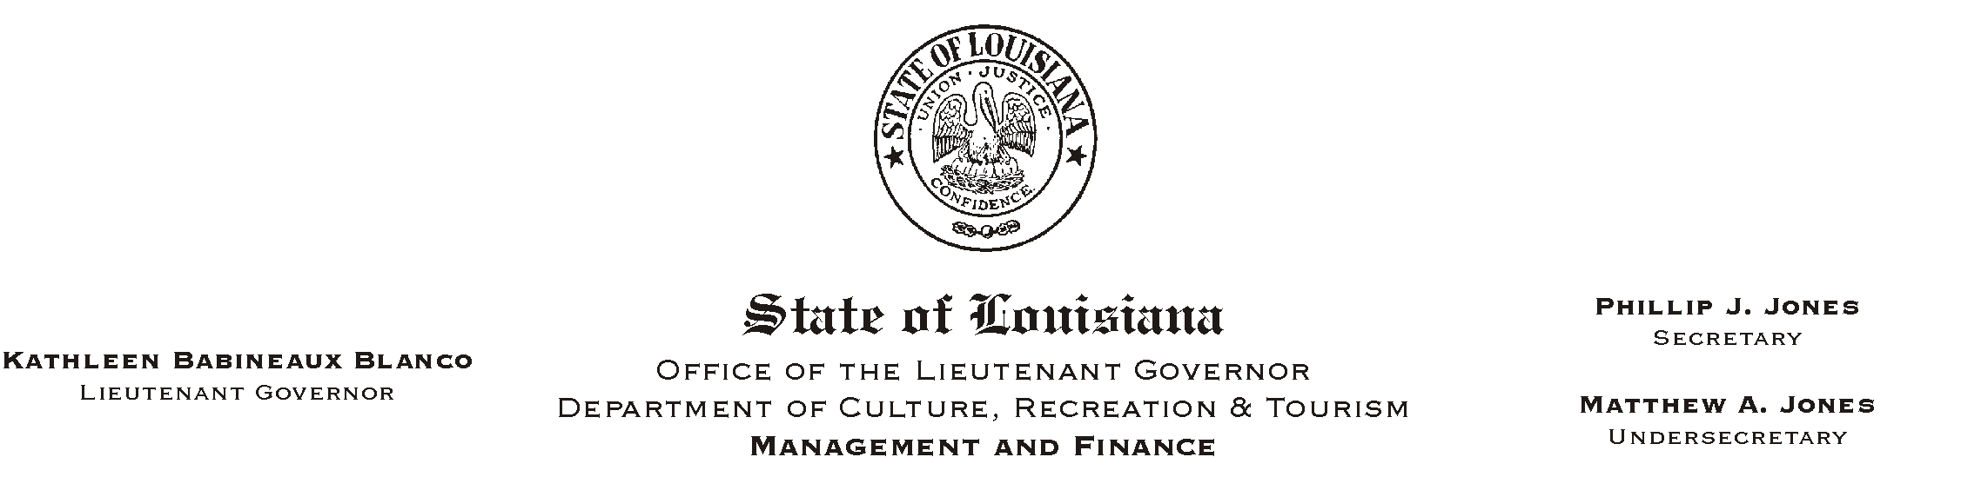

February 1, 2002
Please Post and Circulate
HUMAN RESOURCE MEMORANDUM NO. 02-010

TO: Lt. Governor, Secretary, Undersecretary, Assistant Secretaries, Deputy Assistant Secretaries, Program Managers

FROM: Mary F. Ginn
Human Resources Director

SUBJECT: Election of Participant Member to the Deferred Compensation Commission

Under State Law, the responsibility for management of the Louisiana Public Employees Deferred Compensation Plan is assigned to the Deferred Compensation Commission. Three of the members of that Commission are required to be participants in the Plan and are elected by Plan participants.

The attached notice is designed to provide information to Plan participants concerning the election of a participant member of the Commission for a three-year term commencing on July 1, 2002, and concerning the manner in which participants may become involved in the nomination and election of that member.

Please post and circulate the attached notice in order to make it available to Plan participants in your office.

If you have any questions, please contact the Human Resources Office at (225) 342-0880.

Attachment

Note: HR Memo 02-009 was sent to Baton Rouge employees only.

