
M E M O R A N D U M

TO: ALL PERSONNEL OFFICERS

SUBJECT: ELECTION OF PARTICIPANT MEMBER
LOUISIANA DEFERRED COMPENSATION COMMISSION

DATE: JANUARY 18, 2002

Under State law, the responsibility for management of the State of Louisiana Public Employees Deferred Compensation Plan is assigned to the Louisiana Deferred Compensation Commission. Three of the members of that Commission are required to be participants in the Plan and are elected by Plan participants.

The attached notice is designed to provide information to Plan participants concerning the election of a participant member of the Commission for a three-year term commencing on July 1, 2002, and concerning the manner in which participants may become involved in the nomination and election of that member.

Please read the attached notice, arrange for it to be posted on bulletin boards in your agency, and take such additional measures as will, in your opinion, be best designed to make the information contained in the attached notice available to Plan participants in your agency.

Thank you for your attention to this matter, and your continued support of the Louisiana Deferred Compensation Plan.

EB/sw

Attachment

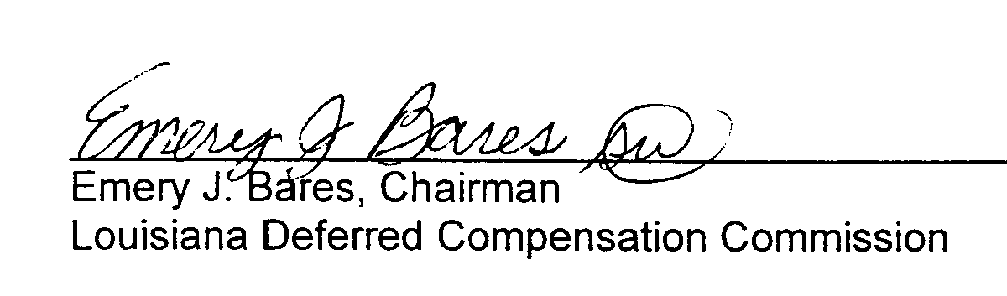


NOTICE
TO ALL PARTICIPANTS IN THE
LOUISIANA PUBLIC EMPLOYEES DEFERRED COMPENSATION PLAN

The Louisiana Deferred Compensation Commission, acting pursuant to Act 1 of 1982 (La. R.S. 42:1301-1308) has adopted a rule governing the nomination and election of participant members, a copy of which is attached hereto, and has, acting in accordance with Section 1 of said rule, appointed a nominating committee consisting of the five participants whose names are as follows:

Truman Bourgeois
Kent LaPlace
Doris Gunn
Norman Sisson
Herb Sumrall

The said committee, having been advised that the three-year term of Robert Lee Borden, LASER's, is scheduled to expire on June 30, 2002, was requested to nominate at least one participant for the new three-year term that commences on July 1, 2002. The Committee, acting in response to that request, has nominated incumbent Robert Lee Borden, LASER's, for re-election to the new term.

Participants are hereby notified that nominations may be made by petition if the petition contains the signatures and social security numbers of twelve (12) participants and is received by the Commission Chairman, Emery J. Bares, 2237 South Acadian Thruway, Suite 702, Baton Rouge, Louisiana 70808 prior to 4:00 p.m. on March 1, 2002. One example of such a petition is attached.

Only participants who have been participants for more than two (2) years may be nominated. A statement signed by the nominee, in which the nominee expresses his or her willingness to serve as a participant member of the Deferred Compensation Commission, if elected must accompany petitioning participants' signatures.

Notice is hereby given that the Commission Chairman will conduct a drawing in the Offices, of the Plan Administrator, 2237 South Acadian Thruway, Suite 702, Baton Rouge, Louisiana at 10:00 AM on March 18, 2002, which drawing shall be conducted for the purpose of determining the position each nominee will have on the ballot. All nominees or their designated representatives are invited to attend the said drawing.

(800) 345-4699 (225) 926-8082 FAX (225) 926-4447

All nominees may submit to the Commission Chairman prior to 10:00 AM on March 18, 2002, a statement containing no more than thirty-five (35) words, which statement shall contain biographical information and/or a statement concerning the nominee's position on one or more issues pertinent to the Deferred Compensation program, for inclusion on the ballot.

The ballots, envelopes, and signature slips needed by participants desiring to cast a vote in the election for a participant member of the Deferred Compensation Commission will be mailed to each participant on or before April 19, 2002. The deadline for returning ballots is 4:00 PM on June 7, 2002. A ballot counting committee will be appointed by the Commission and will meet on June 14, 2002 for the purpose of counting the ballots. The committee will report the results of the election to the Commission Chairman on June 14, 2002.

For further information concerning the election of participant members, please contact Sherry Winkler at 800/345-4699 X1 005.
EB/sw
P E T I T I O N
For Nomination of Participant Member
of Louisiana Deferred Compensation Commission

Petition to Louisiana Deferred Compensation Commission for the candidacy of

_____________________________ .

PETITIONING PARTICIPANTS

Name (Signature) S/S Number

1.__________________________________ _________________________________

2.__________________________________ _________________________________

3.__________________________________ _________________________________

4.__________________________________ _________________________________

5.__________________________________ _________________________________

6.__________________________________ _________________________________

7.__________________________________ _________________________________

8.__________________________________ _________________________________

9.__________________________________ _________________________________

10. ________________________________ _________________________________

11. ________________________________ _________________________________

12. ________________________________ _________________________________

I agree that if elected to membership on the Louisiana Deferred Compensation Commission, I will serve the term to which I am elected.

_____________________________________ _________________________________
Signature S/S Number
_____________________________________ _________________________________
Mailing Address Telephone Number


LOUISIANA DEFERRED COMPENSATION PLAN
2001 PARTICIPANT ELECTION
SCHEDULE OF EVENTS
Nominating Committee meeting - Monday, January 14, 2002
2. Notice to Personnel Departments - Friday, January 18, 2002
3. Deadline for nominating petitions - Friday, March 1, 2002
4. Drawing for position on ballot - 10:00 AM Monday, March 18, 2002
5. Deadline for statement from nominated participants for ballot - Monday, March 18, 2002
6. Ballots mailed to participants with quarterly statements - Friday, April 26, 2002
7. Deadline for return of ballots - Friday, June 7, 2002
8. Ballot Counting Committee will meet to count ballots - Friday, June 14, 2002

(800) 345-4699 (225) 926-8082 FAX (225) 926-4447

