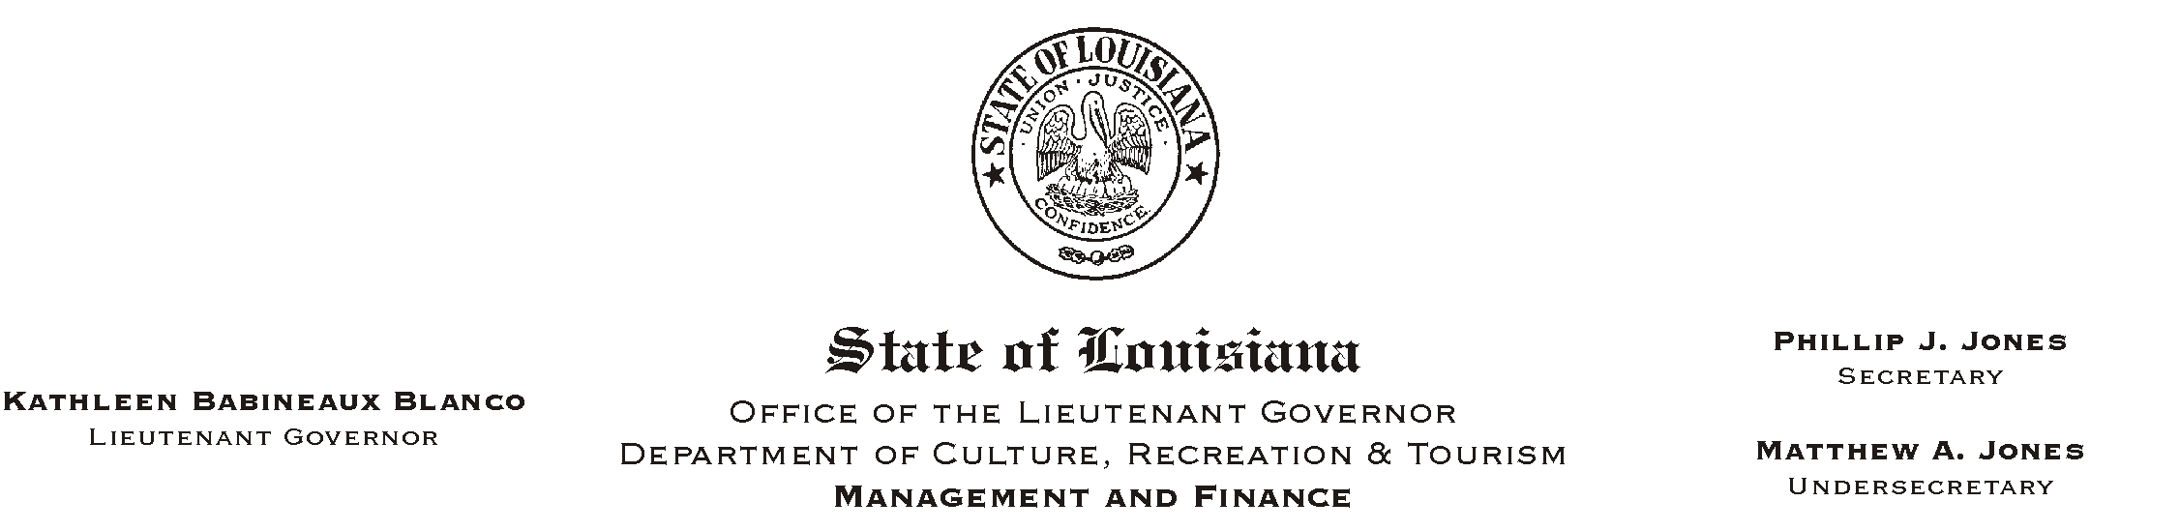
February 15, 2002
HUMAN RESOURCES MEMORANDUM NO. 02-012

TO: Lt. Governor, Secretary, Deputy Secretary, Undersecretary, Assistant Secretaries, Deputy Assistant Secretaries, Program Managers

FROM: Mary F. Ginn
Human Resources Director

SUBJECT: New Requirement for Reference Checking Guides
Please Post and Circulate

On December 31, 1997, we issued Human Resources Memorandum No. 97-062 titled AHiring Winners - Two New Guides to Make Your Job Easier.@ The two new guides were the Interviewing and Reference Checking Guides which remain current today (see attached).

The Department of Civil Service has issued new guidelines now requiring us to maintain in the personnel files copies of all reference checking documents. Reference checking has always been a requirement, but supervisors were not required to submit documentation to Human Resources in the past. Now, copies of all completed reference checking documents must be submitted to the Human Resources Office for all new employees.

Interviewing guides are intended to serve as informal Ascripts@ for supervisors during the interviewing process and as an aide when choosing the best candidate. You are not required to submit copies of the interviewing guide to Human Resources.

When using any guide during both the interviewing and reference checking processes, consistency is very important. The questions you choose to ask applicants or references must be the same for all in a particular hiring situation. For example, when conducting interviews for a clerical position, each applicant should be asked the same questions. When checking the references of applicants for the clerical position, each of the references should be asked the same questions.

If you have any questions, please call the Human Resources Office.

Attachments

