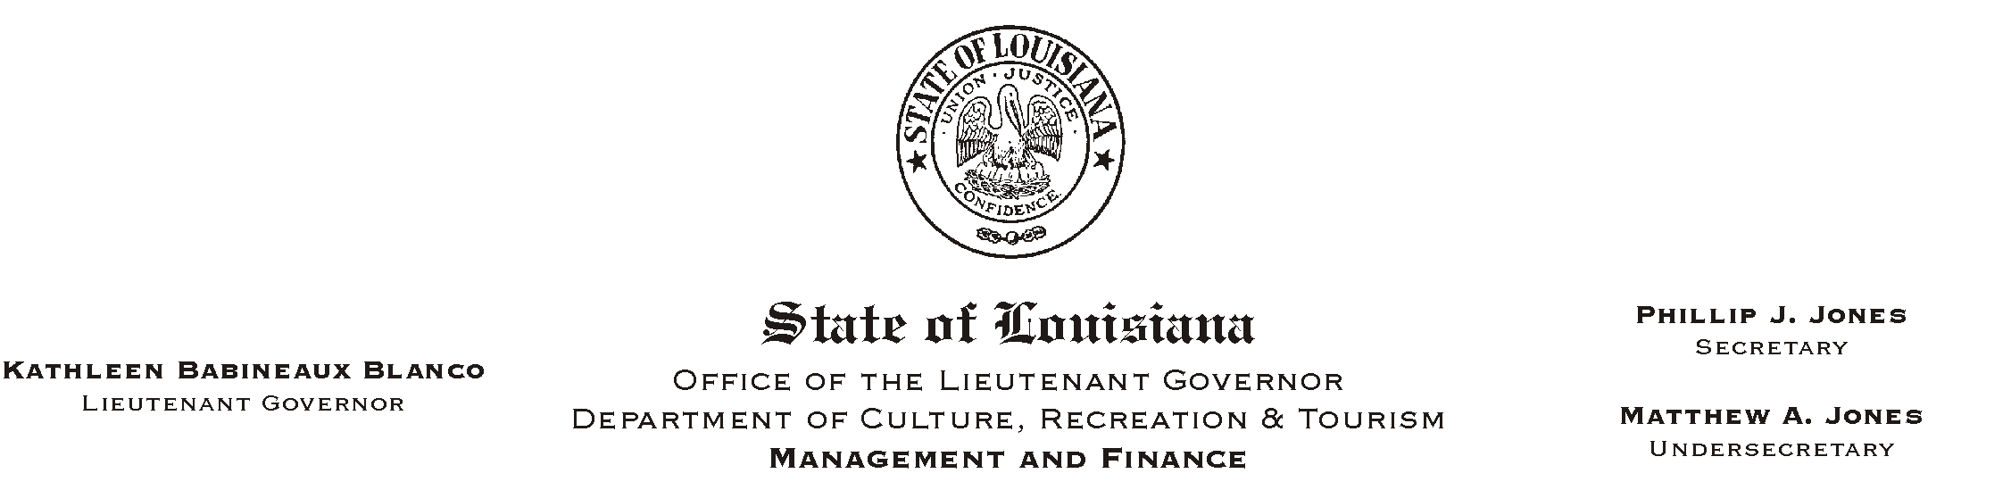
February 28, 2002
HUMAN RESOURCES MEMORANDUM NO. 02-015

TO: Lt. Governor, Secretary, Undersecretary, Assistant Secretaries, Deputy Assistant Secretaries, Program Managers and All Employees

FROM: Mary F. Ginn
Human Resources Director

SUBJECT: New Mandatory Direct Deposit Rule Proposed
Please Post and Circulate
by the Office of State Uniform Payroll

******************************************************************************
IMPORTANT INFORMATION FOR ALL EMPLOYEES
******************************************************************************
Attached is a memorandum from the Office of State Uniform Payroll (OSUP) to all state employees regarding a proposed rule to make mandatory direct deposit a condition of employment. If this rules passes, it will be effective July 1, 2002.

Please read the attached memorandum carefully and send your comments to Kathleen Miller by
e-mail or fax (225) 342-7928 no later than 5:00 p.m., March 15, 2002. We will compile your comments and submit a letter on behalf of the department to OSUP.

If you wish, you may also direct your comments to the Director of the Office of State Uniform Payroll at P. O. Box 94095, Baton Rouge, LA 70804-9095, no later than 5:00 p.m., March 20, 2002.

Attachment

