March 12, 2002
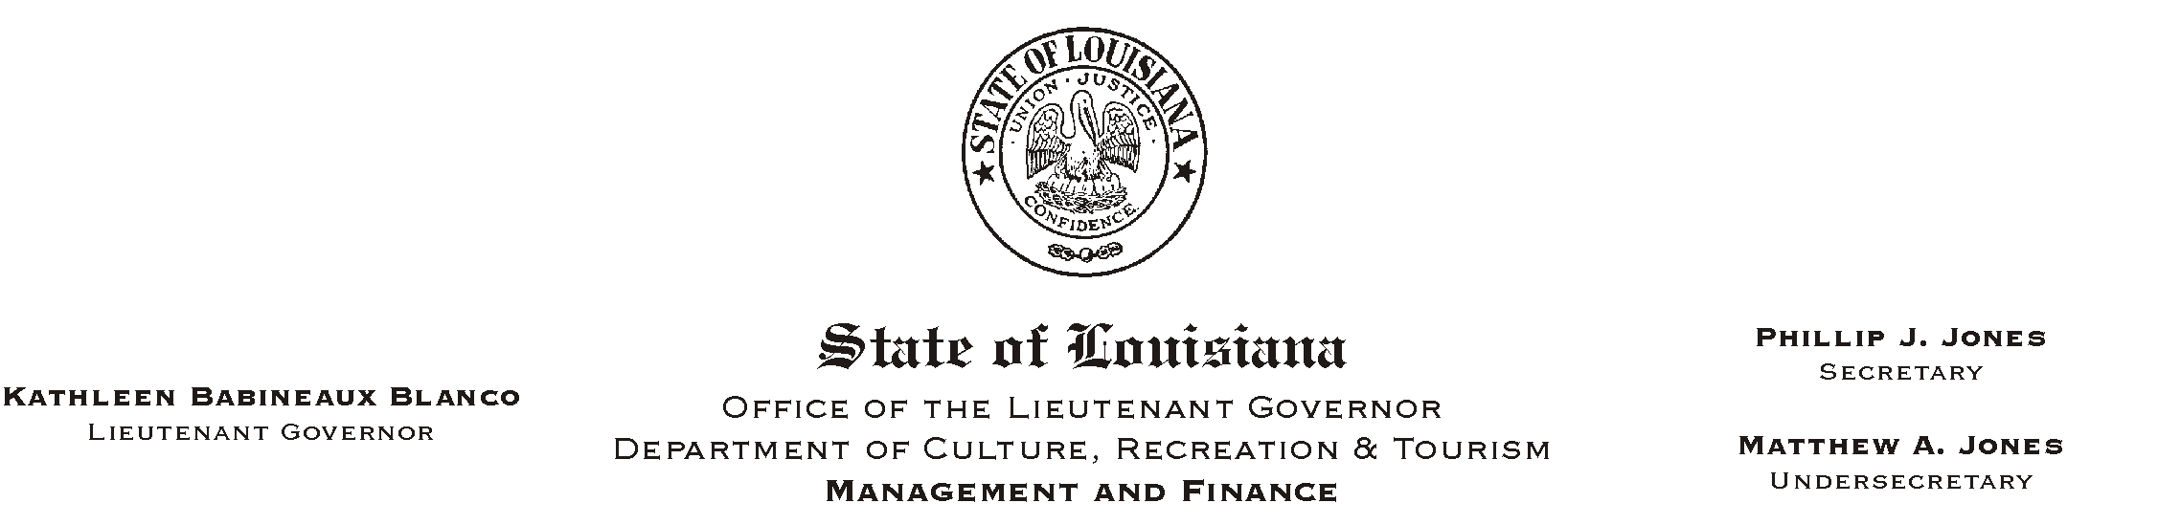

TO: Lt. Governor, Secretary, Undersecretary, Assistant Secretaries, Deputy Assistant Secretaries, Program Managers

FROM: Mary F. Ginn
Human Resources Director

SUBJECT: A Lunch & Learn Workshop - Bomb Threats
Please Post and Circulate
(Another in our series of informational meetings on health and safety)
Bomb Threats
Roy Guggenheim, Louisiana State Police
Thursday, March 28, 2002
11:30 a.m. - 1:00 p.m.
Seminar Center, State Library

You are invited to a Lunch & Learn Workshop presented by Officer Roy Guggenheim of the Louisiana State Police. We will plan to eat lunch at 11:30 and the presentation will begin at 12 noon. Employees can order lunch from AJason=s Deli@ or bring their own lunch. Those who wish to attend the presentation only should still register and arrive no later than 12 noon.

HUMAN RESOURCE MEMORANDUM NO. 01-027
This workshop will also serve as a safety meeting. Please complete the attached registration form and submit it to the Human Resources Office no later than Tuesday, March 26, 2002. Those interested can also register on-line on AChannel Z.@
Please Post and Circulate

HUMAN RESOURCE MEMORANDUM NO. 02-016
Attachment
Please Post and Circulate

