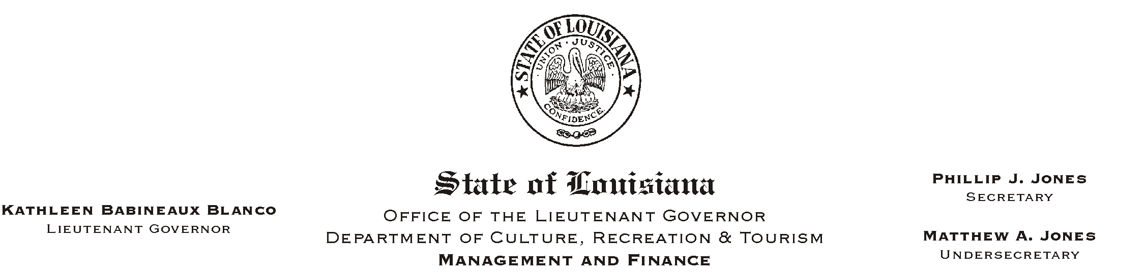
April 3, 2002
HUMAN RESOURCES MEMORANDUM NO. 02-065

TO: Lt. Governor, Secretary, Undersecretary, Assistant Secretaries, Deputy Assistant Secretaries, Program Managers

FROM: Mary F. Ginn
Human Resources Director

Please Post and Circulate
HUMAN RESOURCE MEMORANDUM NO. 02-025
SUBJECT: Flexible Benefits Eligibility Reports
Please Post and Circulate
Flexible Benefits Enrollment Changes
Prudential Life Insurance Certificates of Insurance

Flexible Benefits Eligibility Reports

Enclosed are the Employee Flexible Benefits Eligibility Reports for distribution to employees in your office. These are confidential documents and should be distributed to employees only by a manager. The reports include employees who are both enrolled and not enrolled in the Flexible Benefits Plan. Those who currently have Prudential Life Insurance will also receive a new certificate of coverage booklet attached to their report.

Flexible Benefits

The State of Louisiana Flexible Benefits Plan consists of Premium Conversion and the Dependent Care and Medical Flexible Spending Accounts. Premium conversion allows you to pay your portion of eligible insurance premiums before taxes are calculated. The Dependent Care Flexible Spending Account allows you to pay dependent care expenses for your child, disabled spouse, elderly parent or other dependent incapable of self-care. The Health Care Flexible Spending Account allows you to pay for eligible out-of-pocket medical expenses not covered by your health benefits plan.

HR Memo 02-025
April 3, 2002
Page 2

Flexible Benefits Enrollment

Annual Enrollment is the only time that most employees may join, withdraw or change their participation in the Flexible Benefits Plan. This year, due to the implementation of administrative fees, everyone who wants to participate will be required to enroll during the annual enrollment period, April 1-30, 2002.

1. Premium Conversion Enrollment Form
Enclosed are Flexible Benefits Premium Conversion Enrollment/Stop Forms for Plan Year 2002/2003. Current participants must complete and submit to the Human Resources Office a Premium Conversion Enrollment form if they wish to continue to have their eligible insurance premiums deducted on a pre-tax basis. The forms must be signed in April.

Beginning May 2, 2002, these forms should also be used to enroll new employees in the Premium Conversion part of the Flexible Benefits Plan. Until that date, new hires should complete the Flexible Benefits Enrollment/Stop Form for Plan Year 2001-2002.

2. Flexible Spending Accounts Enrollment Form
To participate in either the new Healthcare Flexible Spending Account or the Dependent Care Flexible Spending Account, employees must complete a separate enrollment form. We did not receive enough Flexible Spending Accounts enrollment forms to distribute to all offices. If an employee wishes to enroll in this part of the Flexible Benefits Plan, please contact the Human Resources Office and we will forward an enrollment form to the employee. When enough forms become available, we will forward them to all offices of CRT.

If there are any questions, please call the Human Resources Office at (225) 342-0880.

Attachments

NOTE: Information on the State Group Benefits Program, including the Summary of Benefits, Newsletter, HMOs, PPO Directory, Life Insurance, Frequently Asked Questions (FAQ), etc., is always available on their web site located at http://www.groupbenefits.org/.
Please Post and Circulate

