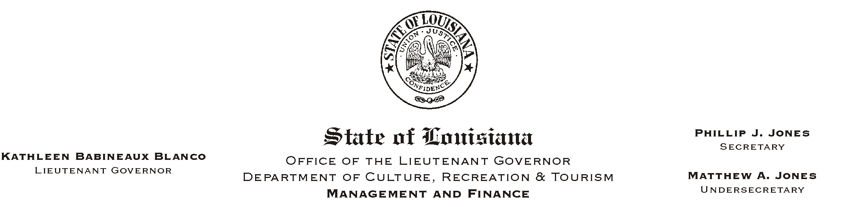
HUMAN RESOURCES MEMORANDUM NO. 02-026

April 4, 2002

TO: Lt. Governor, Secretary, Undersecretary, Assistant Secretaries, Deputy Assistant Secretaries, Program Managers

FROM: Mary F. Ginn
Human Resources Director

SUBJECT: Update to the Mandatory Supervisory Training Groups

Attached is an updated list of the titles for the mandatory supervisory training. Please substitute this list for the list previously attached to Human Resources Memorandum No. 02-017.

The following titles have been added to the Supervisory Group 1 list:

Administrative Manager 4
Engineering Technician 5
Executive Staff Officer
IT Management Consultant 1
Marketing Supervisor
Printing Press Operator Supervisor
Tourism Supervisor

The following titles have been added to the Supervisory Group 2 list:

Administrative Director 3
Tourism Program Director

Once we receive official, updated transcripts from the Comprehensive Public Training Program Office, we will let everyone know what classes they need to attend.

Attachment

