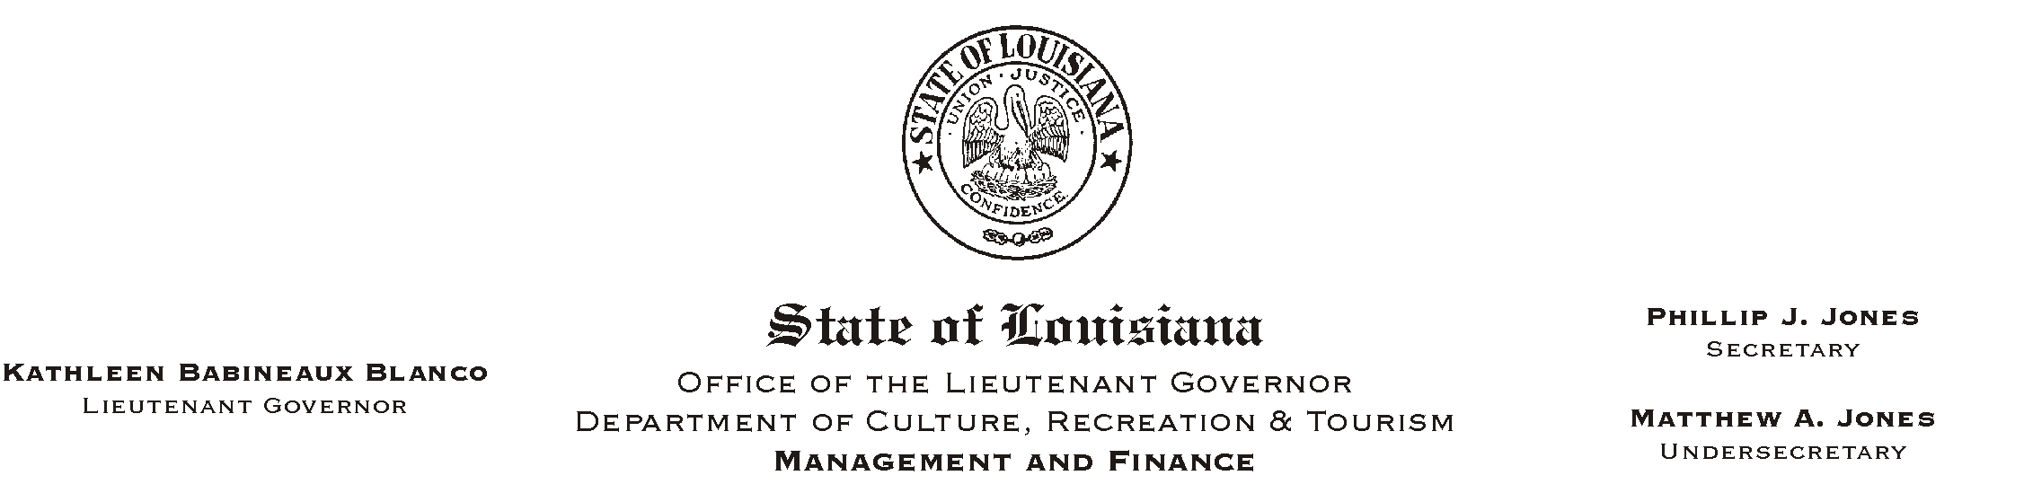
April 10, 2002
HUMAN RESOURCES MEMORANDUM NO. 02-029

TO: Lt. Governor, Secretary, Undersecretary, Assistant Secretaries, Deputy Assistant Secretaries, Program Managers

FROM: Mary F. Ginn
Human Resources Director

SUBJECT: Take Our Daughters To Work Day
Please Post and Circulate
Thursday, April 25, 2002

Last year CRT sponsored a luncheon for Take Our Daughters To Work Day and it was a huge success. This year, the Louisiana Legislative Women=s Caucus and a number of other sponsors are providing lunch free of charge to salute this special day.

The Take Our Daughters To Work Day luncheon will be held Thursday, April 25, 2002 at 12 noon. The event will be held on the lawn of the Governor=s Mansion. A short program will focus on alternative career motivation and education for young girls.

Employees are invited to bring their daughters to work on April 25, 2002 and to enjoy the free lunch provided at the Governor=s Mansion. Please RSVP for lunch by Tuesday, April 23, 2002, to the Legislative Women=s Caucus at (225) 342-0334. A flier with more information about the event is attached.

Attachment

