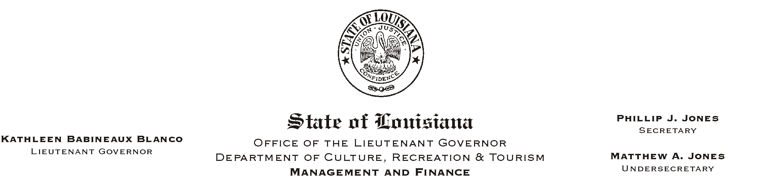
HUMAN RESOURCES MEMORANDUM NO. 02-031

April 15, 2002

TO: All Employees

FROM: Mary F. Ginn
Human Resources Director

SUBJECT: State Employee Recognition Receptions

Governor Mike Foster has proclaimed May 8, 2002 State Employee Recognition Day as a part of the nationwide Public Service Recognition Week which is the week of May 6, 2002 until May 10, 2002. This week and day was established to make the public aware of the services that public employees provide. The week has also been established to recognize and thank employees who dedicate themselves to public service and the hard work and effort they put forth to serve the needs of citizens. We have attached a copy of the Governor’s Proclamation for your review.

Lieutenant Governor Kathleen Blanco and Secretary Phillip Jones will host three Employee Recognition Receptions to thank all employees for their hard work and dedication to the department and to the State of the Louisiana. The schedule of receptions is listed below.

Monday, April 29, 2002 9:30 a.m. at the Greenwood Welcome Center
I-20 Eastbound, Greenwood, LA

Wednesday, May 8, 2002 3:30 p.m. at the U.S. Mint
400 Esplanade Avenue, New Orleans, LA

Friday, May 10, 2002 2:30 p.m. at the State Library Seminar Center
710 North 4th Street, Baton Rouge, LA

If you wish to participate, let us know which reception you will attend by calling the Human Resources Office at (225) 342-0880 or e-mailing Heather Sherlock at hsherlock@crt.state.la.us.

Attachment

Please Post and Circulate

