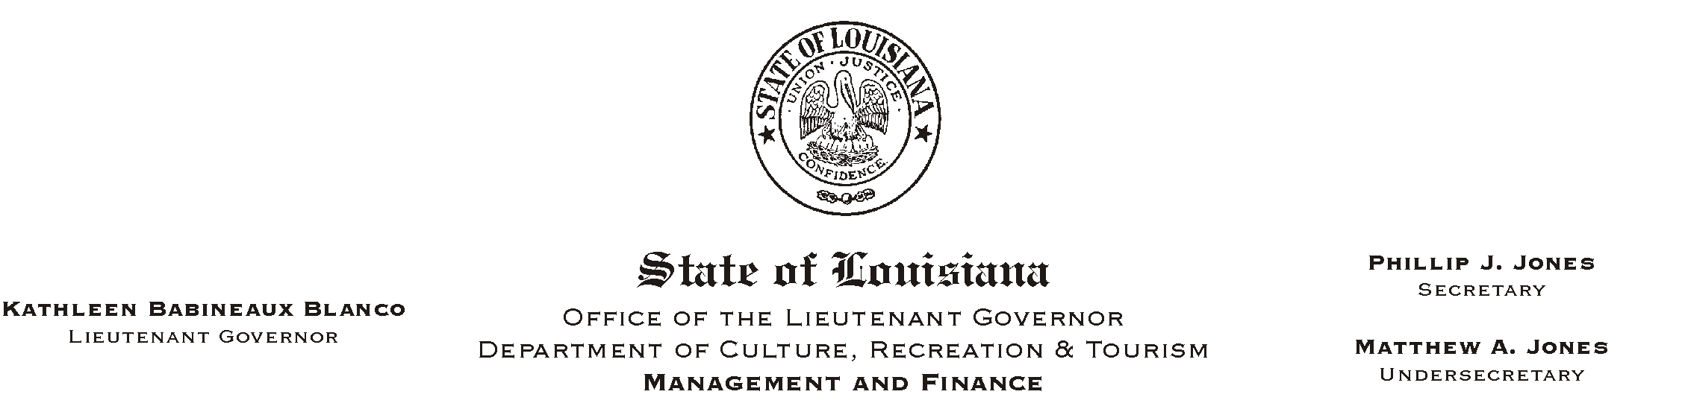
April 15, 2002
HUMAN RESOURCES MEMORANDUM NO. 02-032

TO: Lt. Governor, Secretary, Undersecretary, Assistant Secretaries, Deputy Assistant Secretaries, Program Managers

FROM: Mary F. Ginn
Human Resources Director

SUBJECT: Harassment/Discrimination Training - Mandatory
Please Post and Circulate

Mandatory training sessions have been scheduled for all employees in various locations across the state from April 26 - May 30, 2002. These training sessions are part of our continuing effort to provide periodic reviews and updates of the laws that pertain to employment issues.

All managers, supervisors, and employees must be assigned to one of the scheduled sessions. All training sessions listed below are open to all registrants. Registration lists from agencies and field offices must be submitted to the Human Resources Office at least three days prior to the training dates.

April 26, 2002 | ---------- 1-4 p.m. | Bayou Segnette S.P. | Westwego, LA
May 08, 2002 | 9-12 noon & 1-4 p.m. | Poverty Point S.H.S. | Epps, LA
May 09, 2002 | 9-12 noon & 1-4 p.m. | Lake Bistineau S.P. | Doyline, LA
May 13, 2002 | 9-12 noon & 1-4 p.m. | U.S. Mint | New Orleans, LA
May 15, 2002 | 9-12 noon & 1-4 p.m. | Chicot S.P. | Ville Platte, LA
May 22, 2002 | 9-12 noon & 1-4 p.m. | State Library | Baton Rouge, LA
May 28, 2002 | 9-12 noon & 1-4 p.m. | Lake Fausse Pointe S.P. | St. Martinville, LA
May 30, 2002 | 9-12 noon & 1-4 p.m. | State Library | Baton Rouge, LA

