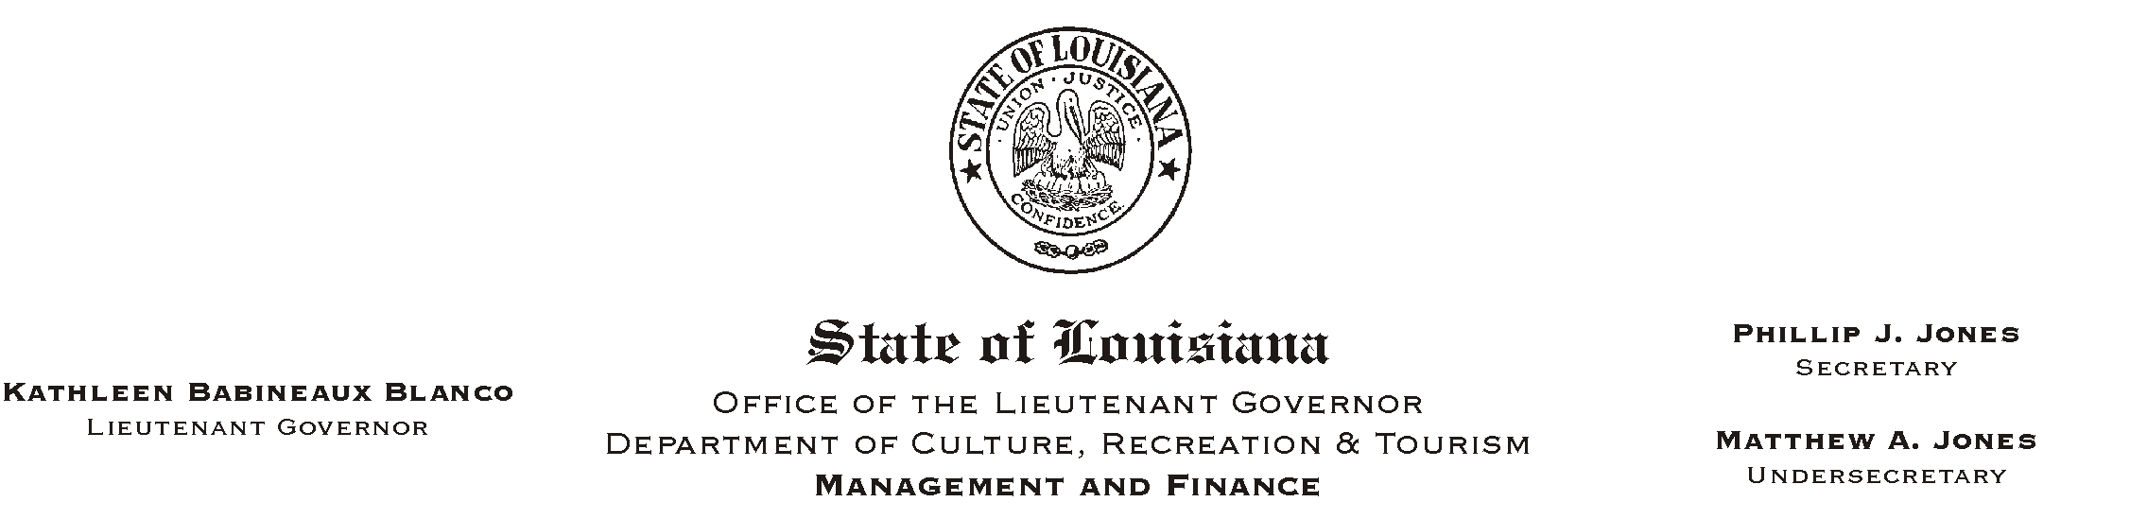
April 18, 2002
HUMAN RESOURCES MEMORANDUM NO. 02-035

TO: Lt. Governor and CRT Employees in the State Capitol Area

FROM: Mary F. Ginn
Human Resources Director

SUBJECT: Food Drive April 29 through May 3, 2002
Please Post and Circulate

The Greater Baton Rouge Food Bank is a non-profit organization which distributes free food to 107 member agencies in 12 parishes. In 2001, more than 4.2 million pounds of food (99.8 percent in donations) were distributed to needy children, the ill, the poor, and the elderly.

Every year donations to the Food Bank decline after the Thanksgiving and Christmas holidays, making it difficult to provide as much food to member agencies. Therefore, state employees are asked to contribute to the food drive in celebration of Louisiana=s 190th birthday. A copy of Governor Foster=s proclamation designating April 30, 2002 as ALouisiana Day Food Drive@ is attached. Please help commemorate the hospitality for which Louisiana is known by helping to feed the hungry in our community.

On Monday, April 29, and continuing through Friday, May 3, 2002, barrels will be placed by the elevators on all floors in the Capitol Annex Building. Please donate non-perishable food items.

Thanks for your participation!

Attachment

