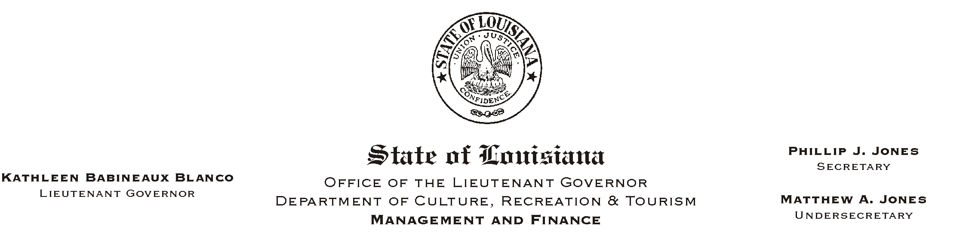
April 25, 2002
HUMAN RESOURCES MEMORANDUM NO. 02-038

TO: Lt. Governor, Secretary, Undersecretary, Assistant Secretaries, Deputy Assistant Secretaries, Program Managers

FROM: Mary F. Ginn
Human Resources Director

SUBJECT: Two Errors Detected in Employee Handbook Revisions
Please Post and Circulate

We are so sorry for this inconvenience, but two errors have been detected in the Introduction section of the Employee Handbook revisions recently distributed. Page i-4 contains a misplaced footnote revision date that obscures some of the text and it has been removed. Page i-8 has an incorrect revision date of 04/04/00 which has been corrected to 04/04/02.

Please copy and distribute the enclosed corrected pages as indicated below:

Remove Replace With
Introduction: Page i-4 Introduction: Page i-4 corrected
Page i-8 Page i-8 corrected

Once again, we are so sorry for the inconvenience. If you have any questions, please call the Human Resources Office at (225) 342-0880.

Enclosures

