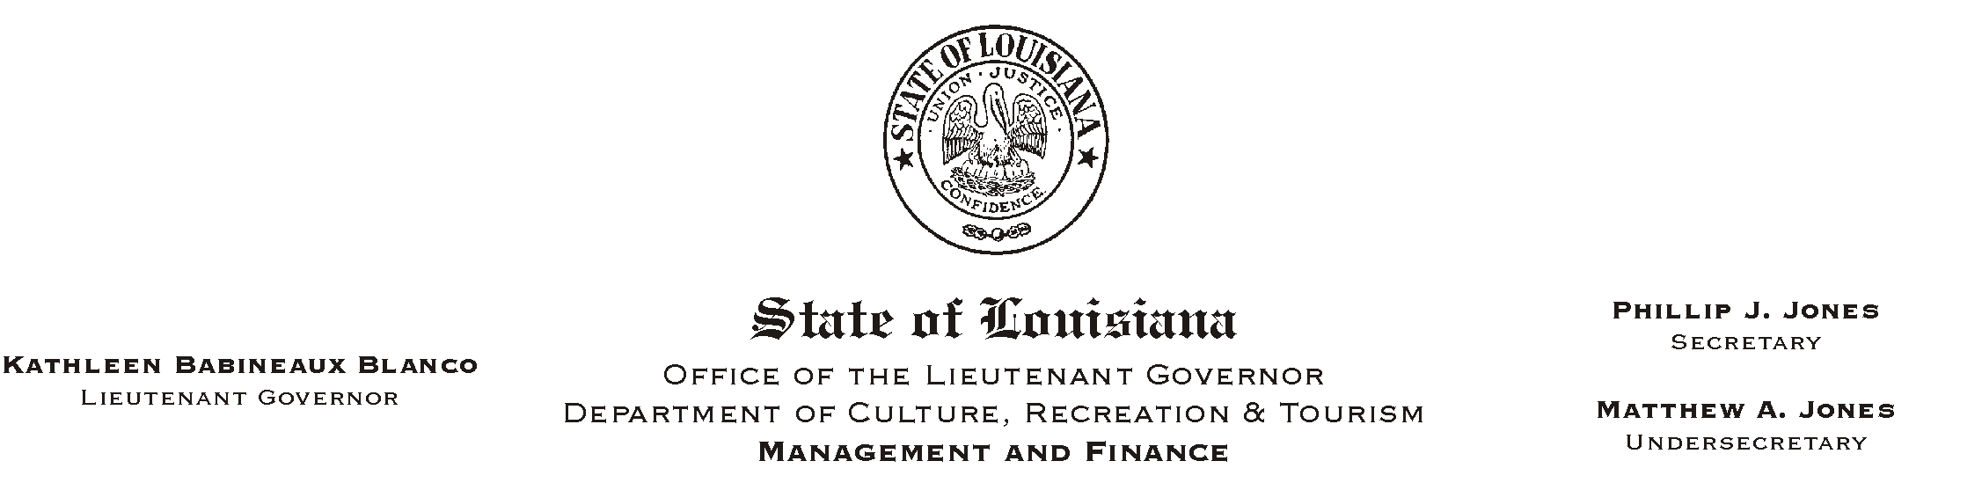
May 7, 2002
HUMAN RESOURCES MEMORANDUM NO. 02-039

TO: Lt. Governor, Secretary, Undersecretary, Assistant Secretaries, Deputy Assistant Secretaries, Program Managers

FROM: Mary F. Ginn
Human Resources Director

SUBJECT: Delinquent/Incomplete Personnel Paperwork Continues
Please Post and Circulate

We are continuing to receive delinquent and incomplete paperwork from field offices. Human Resources Memorandum No. 02-013 dated February 28, 2002 addressed many of the issues (see attached). Some offices have improved, but many have not.

Complete and accurate information from offices is imperative for an employee to receive a pay check and proper benefits. Some offices are faxing only minimum information to Human Resources and then waiting until the last day of the pay period or for as long as 30 days before forwarding the originals. Delays cause overpayments, under-payments, non-payments, insurance and direct deposit problems, and more. Until we enter an employee into the system, timekeepers cannot enter their time. All information must be on the forms.

Offices are also submitting inaccurate 301 forms: missing or incorrect cost centers cause inappropriate expenditures; inaccurate work schedules and missing part time percent FTE (hours worked per week divided by 40 hours = %) cause timekeeping problems and subsequent pay issues; incorrect nature of action causes a multitude of entry problems in ISIS. All paperwork must be complete and ready for entry when received in Human Resources. 301 forms (and any other critical documents) must be faxed immediately and the originals forwarded by mail. Mail forms immediately and never hold paperwork for bulk mailing.

We are continuing to look at several options to provide assistance to you with the orientation paperwork process; however, the feedback we have received has been mixed. If you have any suggestions or ideas on how we can help you improve the completion and processing of employment documents, or if you would like for us to provide additional training for staff (including managers), please e-mail or call Kathleen Miller at (225) 219-9453. Remember, when there is a turnover in the staff person responsible for conducting orientation and submitting the new hire paperwork to us, managers must call to arrange for new training.

Attachment

