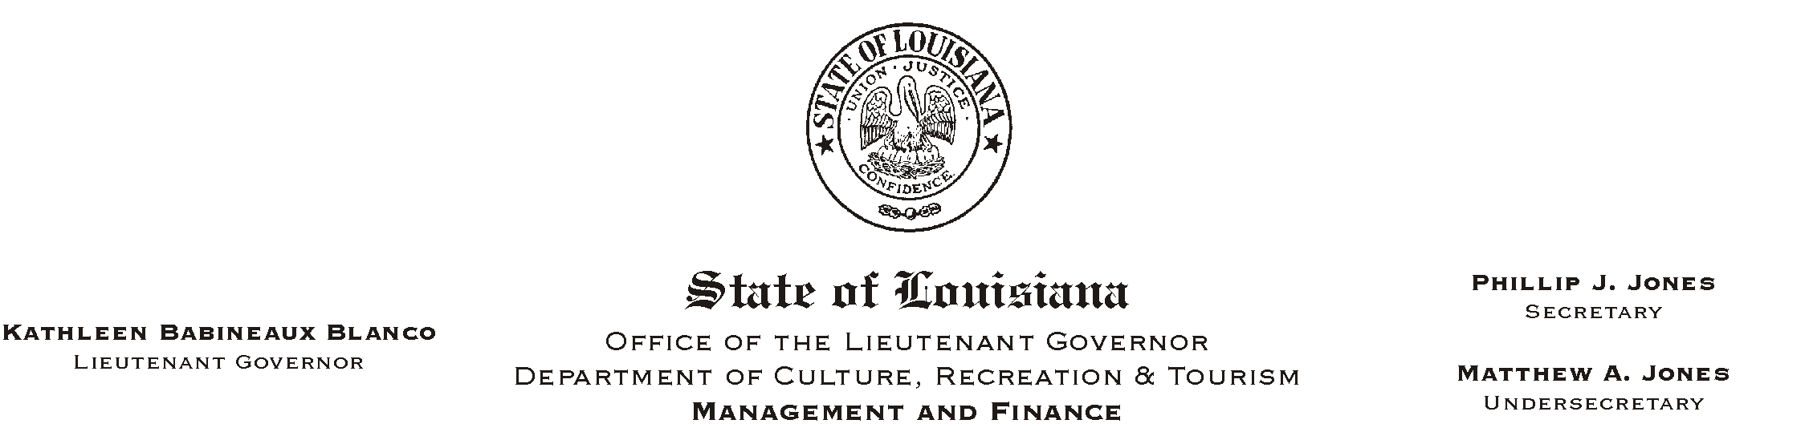
HUMAN RESOURCE MEMORANDUM NO. 02-040

May 7, 2002
Please Post and Circulate

TO: Lt. Governor, Secretary, Undersecretary, Assistant Secretaries, Deputy Assistant Secretaries, Program Managers

FROM: Mary F. Ginn
Human Resources Director

SUBJECT: Memorial Day Holiday/Payroll Deadline

Governor Foster has proclaimed Monday, May 27, 2002, a legal holiday for State workers in observance of National Memorial Day.

Because of this holiday, the Human Resources Office will need all payroll information for the pay period ending May 26, 2002, no later than Wednesday, May 22, 2002. This deadline also applies to employees who need to update their payroll or benefits information (i.e., direct deposit authorization, insurance, addresses, etc.) during this pay period.

If you have any questions, please call the Human Resources Office at (225) 342-0880.

